Titration of Acetic Acid in Vinegar
Minneapolis Community and Technical College
v.3.22

Objective: To practice the correct use of the burette, volumetric pipette, and volumetric flask in analytical titrations.
To determine the acetic acid concentration in store-bought vinegar using titration measurements and stochiometric & dilution calculations.

Prelab Questions: Read through this lab handout and answer the following questions before coming to lab.
There will be a quiz at the beginning of lab over this handout and its contents.

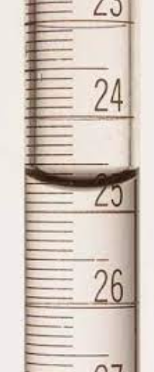
- What is the molar mass of KHP? _{204.22 g/mol}
- What is the purpose of “standardization?”
- What is the mole ratio that connects acetic acid (CH₃COOH) with NaOH?
- What is the approximate concentration of acetic acid in vinegar?
- Correctly read the burette at right. _{24.74 mL +/- 0.01}
- When do we use the NaOH concentration value “0.10 M in calculations?
- How many decimal digits should be reported on all burette measurements?
- How does a rough titration differ from a careful titration?
- What color signals the endpoint of the titrations in today’s experiments?
- Why is it necessary to dilute the vinegar solution before titrating it with NaOH?
- List the steps used to properly fill a volumetric pipette.
- List the steps required when using the volumetric flask to dilute the vinegar in today’s experiment.
- How are a volumetric flask and volumetric pipette alike? How are they different?
- Moles: How many moles of NaOH are there in 34.5 mL of a 0.680 M NaOH solution? _{0.02346 moles}
- Dilution: 20.00 mL of 1.50 M acetic acid is added to a 250.0 mL volumetric flask.
The flask is filled with distilled water to the line.
What is the concentration of the resulting acetic acid solution? _{0.120 M}
- Titration: 0.750 M NaOH is used to titrate a 20.00 mL of an acetic acid solution.
The NaOH initial burette reading is 4.51 mL. The final NaOH burette reading is 31.58 mL.
What is the concentration of the acetic acid? _{1.015 M}

Experimental Technique 1: Burette Operation
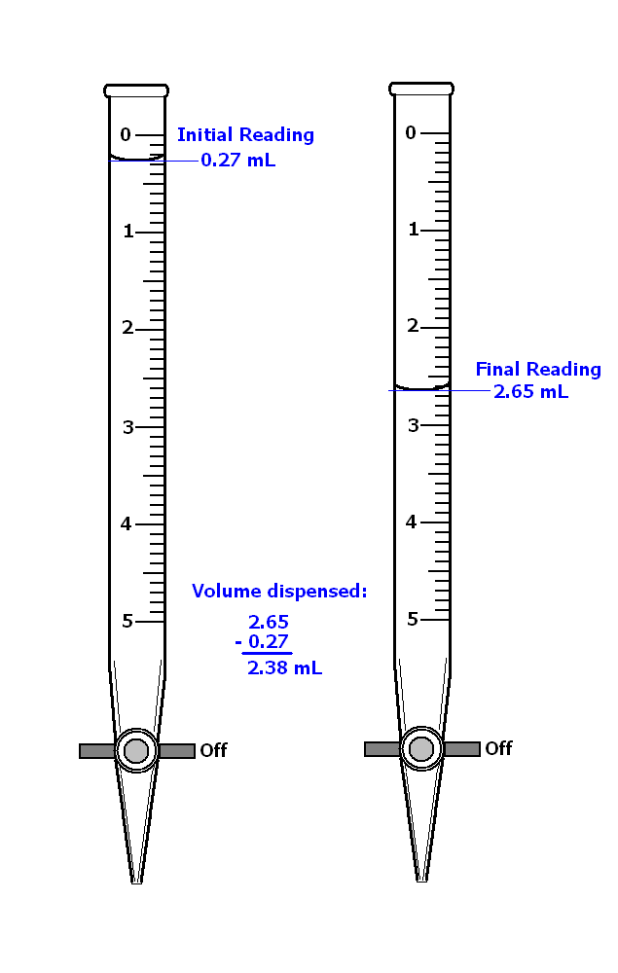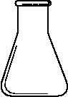
titer
titrant

The burette is a device that is used to dispense a liquid, the titrant, into a flask or beaker containing a different solution, the titer. Before use, the burette must be rinsed with the titrant solution to remove contamination that may be the result of prior use and/or dishwasher residue.

Note also the position of the burette’s valve handle. When perpendicular to the body of the burette, the valve is off. The burets in the figure at right are turned off.

Rinse the burette by first closing the valve and then adding approximately 2-4 mL of titrant solution (record the bottle number). Now tilt the burette (almost horizontal) and allow the titrant solution to run in the direction of the open end. Just as the solution approaches the open end, spin the burette between your fingers but don’t let the solution run out of the burette’s open end onto your fingers!! Discard the rinse solution as instructed. Now rinse the burette a second time.

Fill the burette using a small plastic funnel (valve off). Run out enough liquid to remove any bubbles that may be trapped in the tip. Record the initial reading to 2 decimal digits (see figure at right).

Note that burets are read from the top down UNLIKE graduated cylinders that read from the bottom up. Don’t make the mistake of reading the first buret (figure at above) as 1.73 mL. The correct reading should be 0.27 +/- 0.01 mL.
Slowly add titrant solution until you near the endpoint, signaled by a faint color change (pink for phenolphthalein) that lasts for progressively longer times.

Watch for bubbles that may be hiding in the valve assembly. If you see one, it must NOT be allowed to flow out the burette’s tip. If the bubble comes out, the titration will be in error and must be performed again. You may be able to continue by slowing down the titration.

Look for a color change early on as the titrant solution first encounters the solution in the beaker or flask below. Failure to see a color change means you forgot to add the indicator!

Note: During a titration, the meniscus must always fall on the burette’s graduated scale! Don’t let the meniscus drop below the lowest mark or you will have to repeat the trial!

Two methods may be used to add the last, small amounts of titrant near the endpoint.

- Quickly turn the valve 180 degrees from one off position to the next. When performed quickly enough only a small amount will be added to the beaker. PRACTICE THIS TECHNIQUE PRIOR TO DETERMINING YOUR ENDOINT.
- Slowly open the valve and allow a small partial droplet to form at the end of the burette. Rinse this droplet from the tip of the burette using a small amount of water into the beaker below. The small amount of water should have no effect on your result.

Experimental Technique 2: Pipette Operation
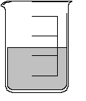
Fill Line
Fill/Empty Lever
Bulb: Squeeze out air.
The volumetric pipette is a device that delivers only one volume of liquid.

The real advantage of the volumetric pipette is that it delivers its one volume very accurately, precisely and reproducibly. For example, a 10 mL volumetric pipette will deliver 10.00 mL +/- 0.02 mL, over and over again.

The volumetric pipette resembles a drinking straw; however you should NEVER place a pipette in your mouth or use mouth suction to fill it.

The pipette is made of glass and has a pointed end like an eyedropper, an enlarged mid-section that is filled with liquid and an upper tube with a fill Line. (figure at right)

Before proceeding, inspect the pipette for cracks and chips. Any damaged pipette should not be used but instead returned to the instructor.

A pipette helper is used to fill and empty the volumetric pipette (see figure at right). Begin by pushing the non-pointed end of the pipette into the tapered hole at the bottom of the pipette helper. Excessive force is not needed. When pushed snuggly into the pipette helper, the pipette will be in no danger of falling out.

Filling the pipette

- Squeeze out the air in the pipette helper bulb. Newer pipette helpers have a large lever that is pushed to squeeze the suction bulb inside the apparatus.
- Position one hand on the pipette helper with the thumb on the fill/empty lever.
- Use the other hand to hold the lower container (beaker) and to stabilize the lower end of the pipette.
- Position the pipette’s tip a little bit off the bottom of the container.
- Push the Fill/Empty lever up to fill the pipette
- Control the speed of the filling operation by adjusting how far you push the Fill/Empty lever
- Stop filling when the meniscus is resting on top of the Fill Line. It may be necessary to fill and/or empty the pipette by pressing the Fill/Empty lever up or down to properly position the meniscus.

Note: Always keep the tip of the pipette immersed in liquid when filling to avoid drawing air into the pipette helper.
Note: Never point a filled pipette upward or lay a filled pipette down on the bench-top as liquid may reach the pipette helper and plug it.

Note: Never draw liquid into the pipette helper. If you do, please alert the instructor immediately.
Emptying the pipette

- Position the filled pipette over the appropriate container
- Press the Fill/Empty lever downwards until the pipette is empty
- Touch the tip of the pipette to the wall of the container to remove the drop that may be clinging to the tip
- A small amount of liquid will remain in the tip of the pipette. LEAVE IT THERE as the pipette was calibrated in this fashion.

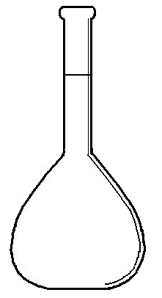Experimental Technique 3: Volumetric Flask Operation
Fill Mark
Keep Dry
Ground Glass Stopper

Volumetric flasks are used to create solutions and to dilute solutions more precisely than would be possible with graduated cylinders. Like a volumetric pipette, the volumetric flask is capable of delivering only one volume. The fill mark is located on the neck of the flask to make it possible to accurately and precisely adjust the volume of liquid.

Filling Procedure

Solutions are prepared by first depositing the solute in the volumetric flask. If the solute is a solid, first insert a long stem funnel into the flask. Pour small amounts of the solid into the funnel and if the funnel becomes plugged, simply rinse the solid through with a small amount of solvent (e.g. water).

Liquid solutes, most often dispensed with a volumetric pipette, are added to the volumetric flask in the same way using a funnel to direct the substance to the bottom of the flask.

Again, using the funnel, add additional solvent (e.g. water). The funnel keeps solvent droplets from being deposited on the inside surfaces of the neck above the fill mark. Droplets stuck above the fill mark will add to the solution’s volume making it greater than it should be.

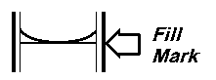
Remove the funnel carefully to keep the flask’s inner neck dry. Continue filling the flask with solvent using an eyedropper (figure at left). When properly filled, the meniscus should appear to rest on top of the etched fill mark.

Mix the solute and solvent (water) by placing the ground glass stopper in the top of the volumetric flask. Be sure to remove the small piece of paper that was wrapped around the stopper during storage.

Place one hand at the top of the flask and hold the stopper in place either using your thumb or two fingers. The other hand should be positioned at the bottom of the flask. Turn the flask upside down and let the movement of the air bubble mix the solution. Repeat this process at least 20 times or until the solid (if that was your solute) has completely dissolved.

EXPERIMENT: Standardization

Today, you will perform a standardization procedure for the sodium hydroxide, NaOH. This procedure improves the accuracy of the NaOH concentration from 0.10M (2 Sig figs) to a value with 4 significant figures. This more accurate concentration will be used in later vinegar calculations.

To standardize the NaOH solution, you’ll perform a titration where it reacts with a solution containing the organic acid potassium hydrogen phthalate (a.k.a. KHP or KHC₈H₄O₄) according to the following balanced chemical reaction:

NaOH_{(aq)} + KHC₈H₄O_{4(aq)} -----> H₂O_{(l)} + NaKC₈H₄O_{4(aq)}

Because the KHP is a solid that is weighed out on an analytical balance, it is possible to determine the number of grams and moles of KHP with 4 significant figures. Consequently, the concentration we calculate for the NaOH also has 4 significant figures.

The results of two standardization titrations are averaged for an NaOH concentration (4 Sig. Fig) that will be used in all future calculations. Note that although the NaOH container is labelled as 0.10 M, that number is never used in any calculations.

NOTE: KHP doesn’t mean potassium (K) hydrogen (H) phosphorus (KHP).
To determine the molar mass of KHP you must use the formula KHC₈H₄O₄

Vinegar Titration

Once you’ve standardized your NaOH solution, you’ll use it to titrate an unknown vinegar solution. Vinegar contains acetic acid (CH₃COOH) that reacts with the NaOH (acid-base reaction) to produce a soluble salt and water:

CH₃COOH_{(aq)} + NaOH_{(aq)} -----> NaCH₃COO_{(aq)} + H₂O_{(l)}

Using the NaOH volume, concentration and the appropriate mole ratio, it is now possible to determine the number of moles of acetic acid that were initially present.

Indicator

The indicator used in all titrations is a phenolphthalein solution that’s added before the titration begins. As NaOH is added to the vinegar or KHP solutions, the base is neutralized by the acetic acid. When the acid is used up, a slight excess of OH⁻ ions develops. These ions react with the phenolphthalein indicator producing the pink color that signals the endpoint of the titration.
An accurate titration “endpoint” is determined when the faintest pink color persists for 30 seconds or more. The volume of the NaOH determined by the endpoint is used to calculated moles and concentration values.

Dilutions

The store-bought vinegar used in today’s experiments contains CH₃COOH at concentrations (~0.8 M) that are too high to titrate with 0.10 M NaOH. For this reason, we’ll perform dilutions that lower the concentration of the acetic acid to a lower level.

Described below is an outline of the dilution process that assumes the concentration of acetic acid in vinegar is known to be 0.850 M. The goal of these dilution calculations is to determine the number of moles of acetic acid that is eventually deposited in a small beaker. The process is the reverse of the process you’ll use when analyzing your experimental data. At that time you will determine the number of moles of CH₃COOH in the small beaker from titration data and then calculate the concentration of the original vinegar solution. That result should be near 0.8 M.

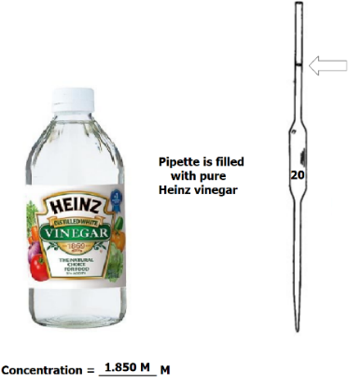

A student fills a 20.00 mL volumetric pipette with Vinegar (figure at right)

The vinegar solution in the pipette has the same concentration as that of the vinegar in the bottle (0.850M).

Since we know the concentration and volume of the vinegar solution in the pipette we can calculate the number of moles of acetic acid in the pipette:

0.850 moles 1L 20.00 mL
moles_{AA} = ------------------- X ----------------- X ----------------- = 0.01700 moles_{AA} …in pipette.
1 L 1000 mL 1

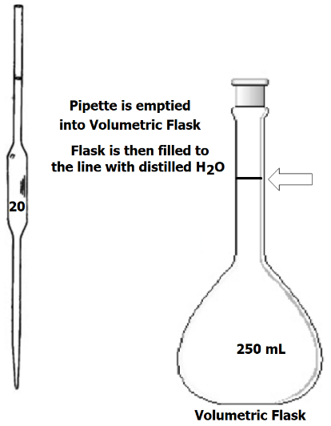
Next, she drains the pipette into a 250.0 mL volumetric flask transferring all 0.01700 moles of acetic acid to the flask.

The 20.00 mL of vinegar are diluted by adding distilled water to the volumetric flask until the fill line has been reached. The volumetric flask is stoppered, inverted and vigorously shaken several times to mix the vinegar and water.

The student now calculates the new concentration of the dilute vinegar since both moles and volume are known:
moles 0.01700 moles
Molarity = -------------------- = -------------------- = 0.06800 M
Volume (Liters) 0.2500 L

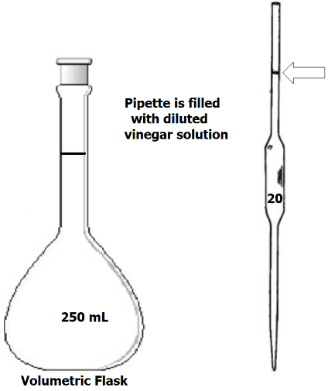
A 20.00 mL volumetric pipette next filled to the mark with the dilute vinegar from the flask.

The vinegar solution in the pipette has the same concentration as that of the dilute vinegar solution in the volumetric flask (0.06800)
M).

Since we know the concentration and volume of the vinegar solution in the pipette we can calculate the number of moles of acetic acid in the pipette:

0.06800 moles 1L 20.00 mL
moles_{AA} = ------------------- X ----------------- X ----------------- = 0.001360 moles_{AA} in pipette.
1 L 1000 mL 1

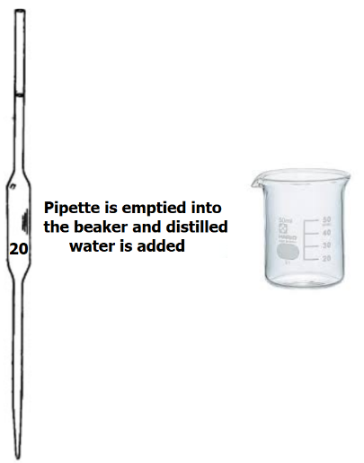
Lastly, she transfers the contents of the volumetric pipette into a small beaker where it will be titrated.

All of the acetic acid, 0.001360 moles, are transferred to the beaker. The contents of the beaker are titrated with NaOH whose concentration was previously standardized.

Experiment: Standardization of NaOH

The purpose of this procedure is to accurately determine the concentration of the NaOH with 4 decimal place accuracy.
- Determine the mass of a clean & dry 100 mL beaker using the analytical balance.

- Weigh out approximately 0.3 grams of KHP (KHC₈H₄O₄) into the 100 mL beaker using a top loading balance (i.e. pre-weigh the KHP).
- Reweigh the beaker and KHP on the analytical balance and determine the amount of KHP to the nearest 0.1 mg (i.e. 4 decimal digits)
- Using the markings on the side of the beaker as a guide, add approximately 30 mL of additional distilled water to KHP.
- Add 3 drops phenolphthalein indicator and a small magnetic stir bar to the beaker.
- Place your beaker/solution/stir bar on the stir plate and stir the solution until all of the KHP has dissolved.
- Obtain approximately 50 mL of 0.10 M NaOH solution in a small beaker and bring it back to your lab station.
- Rinse the 25 mL burette twice with small amounts (1-2 mL) of the NaOH solution.
- Fill the burette with NaOH solution and then drain a small amount of NaOH from the burette to remove bubbles trapped in the tip.
- Remove the funnel from the top of the burette and record in your the initial reading ( 2 decimal digits) on your data sheet.

- Use your burette to slowly add NaOH small amounts of NaOH solution to the 100 mL beaker while stirring.
Avoid stirring so fast that the solution is splashed up on to the sides of the beaker.
- Initially, look for a pink color near where the NaOH enters the bulk solution.
If you fail to see pink you have forgotten to add the phenolphthalein solution and must do so before continuing.
- Rinse any solution that splashes up on the sides of the beaker with a small amount of distilled water from a squirt bottle.
- As the endpoint is reached, the color change will persist for longer times.
Reduce the amount of NaOH you add as your approach the endpoint.
- Accurately determine the endpoint of your titration using the hanging drop technique described above in the burette operation guide.

- When the pink color persists for 30 seconds or more, record the final burette reading with 2 decimal places on your data sheet. Calculate the amount of NaOH dispensed by subtracting the initial and final burette measurements.
- Repeat the above steps for a second KHP sample.
If you clearly missed the endpoint for either trial, perform a third.
Calculate the average NaOH for the two best trials and record it on the data sheet (8 decimal digits).

Experiment: Vinegar dilution

Standard vinegar is too concentrated to titrate using the ~0.1 M NaOH available in this experiment. Therefore, it is necessary to carefully dilute the vinegar with distilled water before titrating.

- Locate your 250 mL volumetric flask, 20 mL volumetric pipette and a pipette helper.
- Pour approximately 30 mL of white vinegar into a clean/dry 50 mL beaker.
- Fill the volumetric pipette with vinegar to the fill mark and dispense the liquid into the 250 mL volumetric flask using good technique (Refer to the volumetric pipette operation description above).
- Place your glass long-stemmed funnel in the volumetric flask and add distilled water until the liquid approaches the measurement mark.
- Remove the funnel from the volumetric flask.

- Continue to add distilled water with a medicine dropper until the liquid’s meniscus and the fill mark are properly lined up. (Keep fill mark at eye level!).
As you fill the volumetric flask, keep the inner surface of the neck dry (i.e. aim carefully with your eye dropper)
- Stopper the flask, hold the stopper securely and invert and shake the volumetric flask. Repeat this process at least 10 times insure thorough mixing of the solution.

Experiment: Titration of dilute vinegar
A 20.00 mL sample of the diluted vinegar is titrated with standardized NaOH solution

- Rinse your 20mL pipette twice with the dilute vinegar solution you prepared in part C. Dispose of your rinse solutions in a waste beaker.
- Pipette 20.00 mL of the solution prepared in part C into a clean 50mL beaker and add 3 drops of phenolphthalein to the beaker.
- Rough Titration #1. Your first vinegar titration is performed crudely and quickly to determine the approximate endpoint of the titration.
  - Fill your burette with fresh NaOH solution
(don’t use a different bottle!).
  - Record the initial NaOH liquid level position on your data table.
  - Add a small magnetic stir bar and add NaOH in big 1 mL increments until the endpoint is approximately reached.
  - Record the burette reading corresponding to the approximate color change.
- Careful Titrations #2 & #3. Use your knowledge of the titration’s endpoint location from step 3 and repeat the vinegar titration CAREFULLY.
  - Quickly add NaOH until you are within several mL of the endpoint
  - Proceed carefully using small increments until a light pink color is obtained.
  - Record your initial and final burette readings in the data table and calculate the volume of NaOH used for each of these two trials.

NaOH Standardization

 |  |  | KHP  Trial 1 | KHP  Trial 2 | KHP  Trial 3
Mass _{100mL Beaker} |  | grams
Mass _{100 mL Beaker + KHP} |  | grams
Mass _{KHP} |  | grams
Molar Mass _{KHP} |  | g/mol
Moles _{KHP} |  | mol
NaOH: Burette Vol _{initial} |  | mL
NaOH: Burette Vol _{final} |  | mL
Volume: NaOH |  | mL
Moles: NaOH |  | mol
Concentration: NaOH |  | M | _{8 decimal digits} | _{8 decimal digits} | _{8 decimal digits}
Average Concentration: NaOH |  | (mol/L) | _{8 decimal digits}

Vinegar Titration
 |  | Vinegar  Titration  ROUGH  Trial 1 | Vinegar  Titration  CAREFUL  Trial 2 | Vinegar Titration  CAREFUL  Trial 3
Average Concentration: NaOH | (mol/L)
NaOH: Burette Vol_{initial} | mL
NaOH: Burette Vol _{final} | mL
Volume: NaOH | mL
Moles: NaOH | mol

