Calorimetry and the Heat of a Reaction
Principles of Chemistry 1
Version 3.22

Prelab Questions
- Why is heat not used when stirring the calorimeter?
- In the first experiments, a copper cylinder is heated in boiling water. Why?
- Water has a specific heat of 4.184 J/gºC. How much heat energy is required to warm 45.0 grams of water from 25.2ºC to 36.8ºC?
- Why is Styrofoam used in the construction of the calorimeter cup?
- What is the purpose of the calorimeter’s lid?
- What is the purpose of procedure 1?
- What is the purpose of procedure 2?
- Why is the ΔT for the calorimeter the same as the ΔT of the water (or solution)?
- In procedure 1, why is it important to move the hot copper cylinder quickly from the boiling water and into the calorimeter?
- A 5.00 gram piece of metal absorbs 120. Joules of heat energy. It’s temperature goes up from 23.5ºC to 32.9ºC. Calculate the specific heat of the metal.
- The inner calorimeter support that’s used with the two metal cylinder trials, must also be present for the third acid/base even though there’s no metal to support. Why?
- Given the following masses, determine the mass of the water:
mass (empty calorimeter) = 154.33 grams
mass (+H₂O ) = 256.45 grams
mass (+H₂O + Cu) = 298.15 grams
- Is it a problem to mix up the hot/stir plates in Procedure 2? Why?
- What is the word that’s used to describe a substance’s release of heat energy?
- The instructions that accompany a YETI travel mug tell you rinse the cup with hot water before adding hot chocolate or coffee. Why?

Introduction to Calorimetry
Constant pressure calorimetry is an experimental technique used to measure the heat released or consumed by a chemical reaction. It’s “constant pressure” because the entire experiment is done at atmospheric pressure. The action takes place in an insulated cup known as the calorimeter that’s insulated to keep the outside surroundings from affecting the results. A good calorimeter, like a YETI travel mug, is designed to keep hot things hot and cold things cold regardless of the outside temperature.

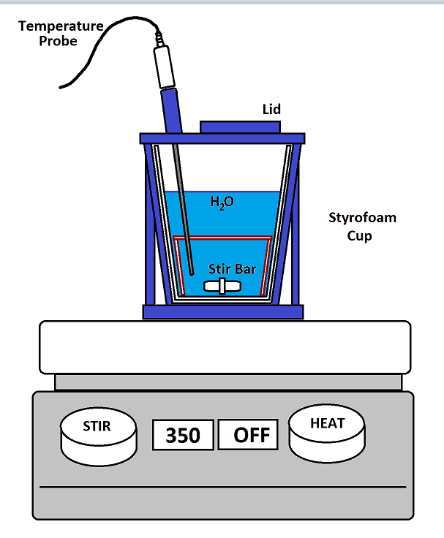
At right is a diagram of the calorimeter apparatus you’ll be using in this experiment. The key features are:
- Styrofoam coffee cup.
Styrofoam is a great insulator and is at the heart of this apparatus. The blue support structure protects the cup, supports the temperature probe and provides a lid that keeps heat from escaping out the top.
- H₂O (or some other solution):
The water or solution in the Styrofoam cup is what gains or loses heat energy as indicated by temperature increases or decreases respectively.
- Temperature probe.
The temperature probe monitors the temperature of the liquid in the calorimeter.
- Stir bar.
The stir bar mixes the contents of the calorimeter with the help of the stir plate below. This insures that the temperature measured by the temperature probe is the same for the solution everywhere.
Note that the stir plate “HEAT” function is turned off. This is necessary to keep from melting the apparatus.
- Lid
The lid is closed during the experiment to keep heat from moving in or out of the calorimeter.

Calculating heat transfer
In the experiments that follow, the water (or solution) gains heat energy and is calculated as follows:
q_{H2O} = m_{H2O} × c_{H2O} × ΔT_{H2O}
where q is the heat, m is the water’s mass in grams, c is water’s specific heat (4.184 J/gºC) and ΔT is the change in temperature (T_{f} – T_{i}). In experiments involving aqueous solutions, we’ll use water’s specific heat in these calculations.
However, while water gains heat energy, so does the calorimeter. Yes, we’ve designed the calorimeter to be as insulating as possible, but even so the cup, stir bar and temperature probe interact and lead to heat absorption.
We can calculate the amount of heat absorbed by the calorimeter as follows:
q_{calorimeter} = C_{calorimeter} × ΔT _{calorimeter}
where q is the heat absorbed by the calorimeter, C is the calorimeter constant (J/ºC) and ΔT is the change in temperature (T_{f} – T_{i}). Mass is not used in this calculation.
It’s important to note that the calorimeter constant must be determined experimentally and this is the purpose of procedure 1 where we use a known mass of hot copper metal to determine C.
Lastly, one can combine the two equations above to determine the total heat gained (or lost) during the process:
q_{total} = m_{H2O} × c_{H2O} × ΔT_{H2O} + C_{calorimeter} × ΔT _{calorimeter}
Since the calorimeter and water are in contact with one another their respective ΔT’s are the same.

Procedure 1
In procedure 1, we’ll prepare the calorimeter with room temperature distilled water and then add a copper cylinder that’s been heated up to 100ºC.
By measuring the final temperature, we’ll calculate the total heat released by the copper cylinder:
q_{Cu} = m_{Cu} × c_{Cu} × ΔT_{Cu} where c_{Cu} = 0.385 J/gºC
Now, the heat lost by the copper is gained by the water and calorimeter. However, a negative sign is required to make the mathematical signs work out. This equation is used to determine the calorimeter constant, C_{calorimeter}.

q_{total} = - q_{Cu}
…or…
m_{H2O} × c_{H2O} × ΔT_{H2O} + C_{calorimeter} × ΔT _{calorimeter}= - m_{Cu} × c_{Cu} × ΔT_{Cu}

Procedure 2
In procedure 2, the same ideas are used except that we’ll use the average calorimeter constant determined in Procedure 1 to determine the specific heat of an unknown metal cylinder.

Procedure 3
In procedure 3, no metal is used. Rather, 50mL HCl is combined with 50 mL NaOH. The resulting acid/base neutralization reaction releases heat (exothermic). Temperature measurements and the mass of the combined solutions are used to determine the total heat produced by the reaction assuming that the solution is dilute enough to use the specific heat of water:
q_{total} = m_{solution} × c_{H2O} × ΔT_{solution} + C_{calorimeter} × ΔT _{calorimeter}

Experimental Procedure 1:
Determination of the calorimeter constant
The purpose of this trial is to determine the calorimeter constant, C_{cal}, for your calorimeter. You will repeat this procedure twice, calculate the calorimeter constant for each trial, and then compute the average of the two calorimeter constants. This value will be used in Experiments 2 and 3 where we’ll need a value for the calorimeter constant to complete the calculations.
- ½ fill a 800 mL beaker with tap water. Sink a 50 mL beaker in the water and position it off to the side
- Add a large stir bar to the 800 mL beaker.
- Weigh the dry copper cylinder on a top loading balance and then place it in the submerged 50 mL beaker.
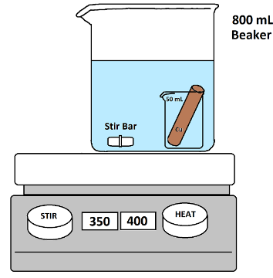
- Place the 800 mL beaker and its contents on a hot plate and heat strongly while stirring. We will need the water to boil.
- While heating the copper, weigh the dry/empty calorimeter on a top loading balance. Include the stir bar, lid and internal support in this measurement.
- Use a graduated cylinder to measure out 100 mL of room temperature distilled water and pour into the calorimeter.

- Weigh the calorimeter a second time and determine the mass of the water.
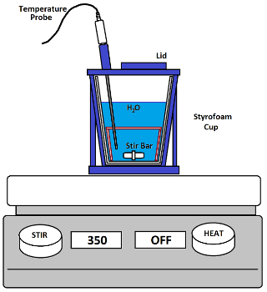
- Place the calorimeter on a COLD stir plate and adjust the stirring rate to 350 RPM.
- Insert the temperature probe and make sure the stir bar is centered and spinning at the bottom.
- Plug the temperature probe into channel 1 and activate LoggerPro.
- When the water heating on the hotplate has been boiling for several minutes, we can assume that the temperature of the water and the copper cylinder are 100ºC.
a. Click the LoggerPro “Collect” button to
begin data acquisition
b. Collect data for 30 seconds
c. Open the lid on the calorimeter
d. Use the tongs to quickly transfer the
copper cylinder to the calorimeter
The copper shouldn’t touch the temp probe.
e. Close the calorimeter lid.
f. Continue collecting data until the
maximum temperature has been
reached and click “Stop”
- Determine the temperature of the water right before the copper was added. This is T_{i}
- Determine the temperature of the water at its highest point. This is T_{f}.
- Empty and carefully dry your calorimeter. Repeat this experiment a second time.

Experimental Procedure 2:
Determination of an unknown metal’s specific heat
The purpose of this trial is to determine the specific heat for an unknown metal cylinder using the calorimeter apparatus above. This value will be used to identify the metal.
Repeat the above steps using the unknown cylinder instead of the copper cylinder. Perform two trials as we’ll average the results.

Experimental Procedure 3:
Heat measurements for an acid/base neutralization reaction
The purpose of this experiment is to determine the amount of heat released as a product (exothermic) of this acid/base neutralization reaction:

HCl_{(aq)} + NaOH_{(aq)} → H₂O_{(l)} + NaCl_{(aq)}
acid base water salt

- Empty and carefully dry your calorimeter.
- Reassemble the calorimeter(stir bar, support and lid) and weigh it on a top loading balance.
- Carefully measure out 50.0 mL of 1.00 M NaOH and 50.0 mL of HCl in two, clean 100 mL graduated cylinders.
- Pour the contents of the HCl solution into the calorimeter cup.
- Close the lid and insert the temperature probe.
- Position the calorimeter on the stir plate and stir at the 350 rpm setting. (Heat turned off!)
- Click on “Experiment” -----> “Store Latest Run”.
- Click “Collect” and continue to collect data for approximately 30 seconds.
- As you continue to collect data, open the calorimeter’s lid and quickly (& carefully) pour in the NaOH solution.
- Close the lid and collect data for 30 seconds then click “Stop”.
- Use LoggerPro to identify the initial and final (maximum) temperatures.
- Weigh the calorimeter apparatus with its neutralized acid/base mixture on a top loading balance.
- Record this measurement in your data table.
- Dispose of the neutralized solution by carefully pouring it down the drain.
- Rinse and dry the calorimeter. Perform a 2nd trial.

Procedure 1 | TRIAL 1 | TRIAL 2
Mass_{calorimeter} (empty)
Mass_{calorimeter} (+H₂O)
Mass_{Cu}
T_{i}
T_{f}

Procedure 2 | TRIAL 1 | TRIAL 2
Mass_{calorimeter} (empty)
Mass_{calorimeter} (+H₂O)
Mass_{metal}
T_{i}
T_{f}

Procedure 3 | TRIAL 1 | TRIAL 2
Mass_{calorimeter} (empty)
Mass_{calorimeter}
(+ combined solutions)
T_{i}
T_{f}

