Experiment: Synthesis of Alum

Minneapolis Community and Technical College

v. 1.22

Objectives: To synthesize alum from aluminum foil, predict the theoretical product yield, measure the actual yield and calculate a percent yield.

Prelab Questions: Read through this lab handout and answer the following questions before coming to lab.
There will be a quiz at the beginning of lab over this handout and its contents.

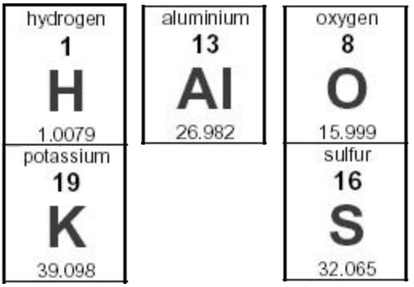
- What is the molar mass of Alum? AlK(SO₄)₂⋅12H₂O (Answer: 474.3796 g/mol)
- What is a hydrate?
- How many aluminum atoms are required to make one alum unit?
- Where does the sulfate ion in the alum product come from?
- Where does the potassium ion in the alum product come from in this experiment?
- What’s the difference between gravity and vacuum filtration?
- How should the end of the funnel be positioned when performing a gravity filtration?
- What is the purpose of the glass stirring rod when decanting?
- What is the correct way to construct an ice bath?
- When do alum crystals form in the experiment?
- At the end of the day, how is the filtration solution disposed of?
- Convert 0.7012 grams of aluminum metal into moles of aluminum metal. (answer: 0.02599 mols)
- What are the first and last measurements you’ll make in lab today?
- How should your laboratory station look at the end of the day?

Alum Synthesis

Alum is a material that has many uses and is commercially available in the baking isle of most grocery stores. Traditionally, cooks have used alum as part of the pickling process where it works both to preserve and firm up the pickles. In water purification processes, dissolved alum reacts with negatively charged particles producing a gelatinous precipitate (a.k.a. a “floc”) that can be removed from the water sample after settling.

In this activity, you will be preparing potassium alum from aluminum metal using sulfuric acid and potassium hydroxide. Alum’s chemical formula:

AlK(SO₄)₂ • 12H₂O

tells us that not only is alum a salt (metal/non-metal) but it’s also a hydrate with twelve water molecules imbedded in the salt’s crystalline structure.

Thus, the chemical name for alum is aluminum potassium sulfate dodekahydrate.
Alum Synthesis: Chemical Reactions

A series of chemical reactions occurs as you convert aluminum metal into alum. The first dissolves the aluminum metal when immersed in hot, aqueous potassium hydroxide. The reaction also liberates hydrogen gas.

2Al_{(s)} + 2KOH_{(aq)} + 6H₂0_{(l)} → 2K⁺_{(aq)} +2Al(OH)₄⁻_{(aq)} + 3H_{2(g)}

Next, sulfuric acid is added to the reaction mixture producing an aluminum hydroxide solid precipitate.

2Al(OH)₄⁻_{(aq)} + H₂SO_{4(aq)} → 2Al(OH)_{3(s)} + 2H₂O_{(l)} + SO₄²⁻_{(aq)}

With additional sulfuric acid and continued stirring, the aluminum hydroxide precipitate re-dissolves:

2Al(OH)₄⁻_{(aq)} + 3H₂SO_{4(aq)} → 2Al³⁺_{(aq)} + 3SO₄²⁻_{(aq)} + 6H₂O_{(l)}

When the products of this last reaction are cooled in an ice bath, the final alum product precipitates:

K⁺_{(aq)} + Al³⁺_{(aq)} +2SO₄²⁻_{(aq)} + 12H₂O_{(l)} → KAl(SO₄)₂·12H₂O_{(s)}

This last reaction tells us that we can form one alum formula unit from each aluminum atom.

In our experiment, all reactants will be in excess (i.e. too much) except the aluminum metal which is referred to the limiting reactant.

Procedure 1: Aluminum/KOH reaction

- Using an analytical balance, pre-weigh
a 250 mL beaker.
- Use a scissors to cut up your aluminum foil into
small pieces and place between 0.9 g and
1.1 grams of aluminum foil pieces the
250 mL beaker.
- Reweigh the beaker with the aluminum foil and
determine the mass of the aluminum foil.
- While working in the hood, use the provided
graduated cylinder to add approximately
50 mL of 1.4 M KOH (potassium hydroxide) to
the reaction beaker containing the aluminum foil.
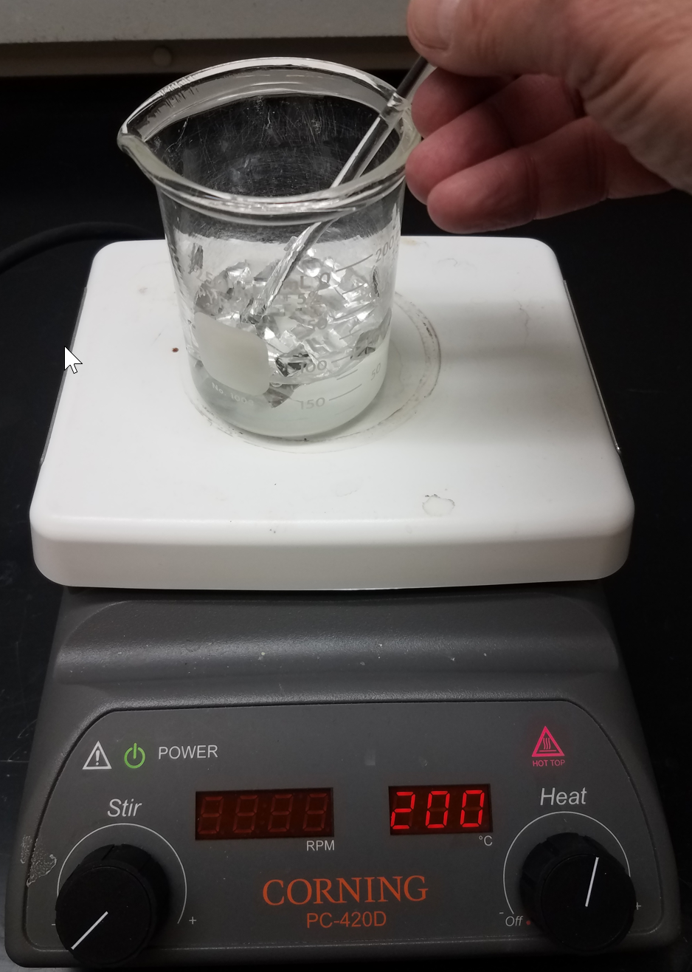
- Continue working in the hood and warm the
reaction mixture using a hotplate. (200ºC).
- Stir the contents of the beaker with a glass
stirring rod to keep the aluminum foil in solution
as it will sometimes stick to the sides of
the beaker.
- When the reaction is complete (you decide)
remove the beaker from the hotplate and allow
it to cool for several minutes in the hood.

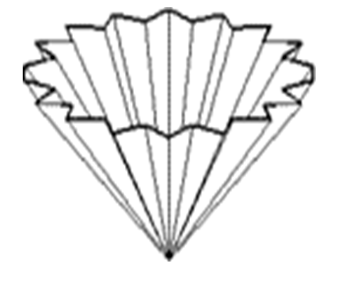
Procedure 2: Gravity Filtration
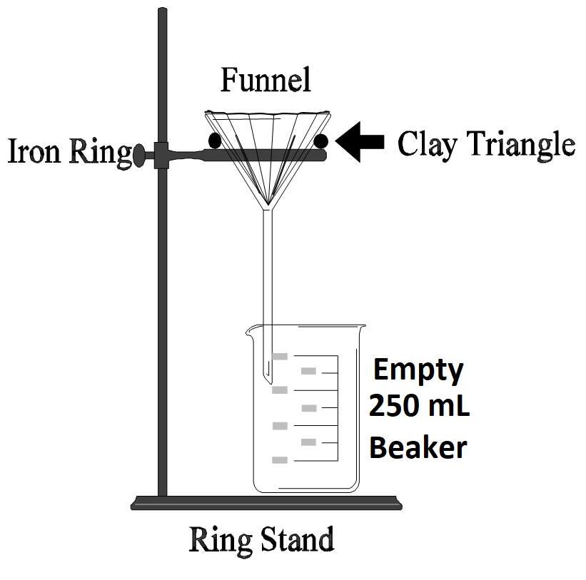
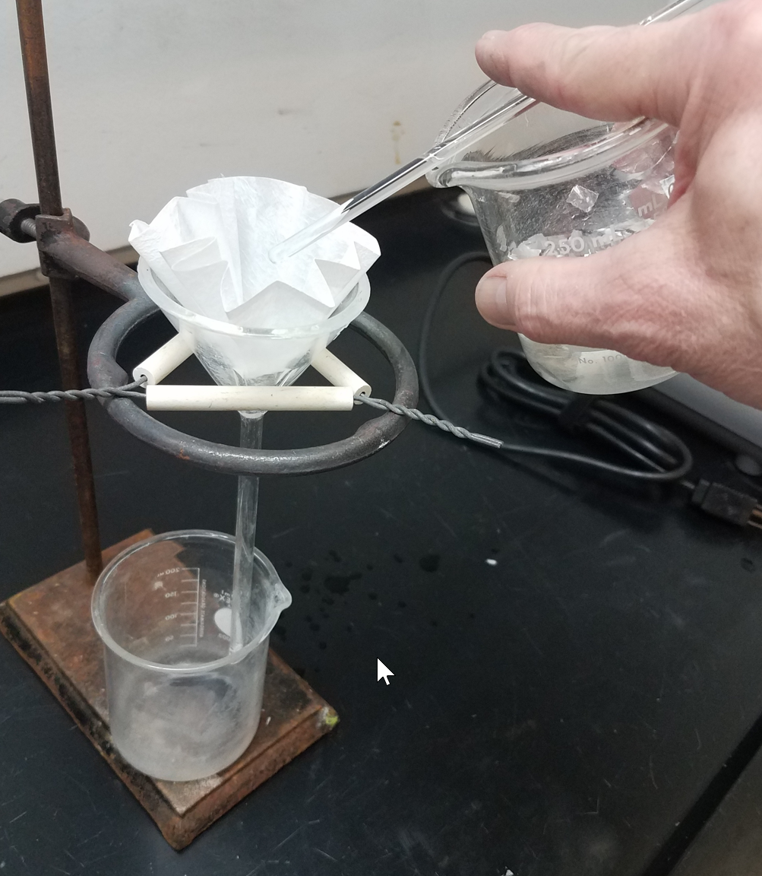
- Assemble the gravity filtration apparatus
(above) in your hood space.
Your instructor will demonstrate how
to flute (fold) your filter paper for this step.

- When cool enough to handle, pour the
contents of the 250 mL reaction beaker
into the gravity filtration apparatus.
Position the glass stirring rod (above) on top of
the beaker to guide (decant…look it up)
the liquid into the funnel.
Don't overfill the funnel.

- Dispose of the gravity filter paper as instructed
(your instructor may pick it up for you).
- Wash, rinse and dry the filter funnel before
returning it to the ring stand.
Procedure 3: Alum Crystallization

- Measure the temperature of your reaction mixture using a glass thermometer and record this value on your data sheet.
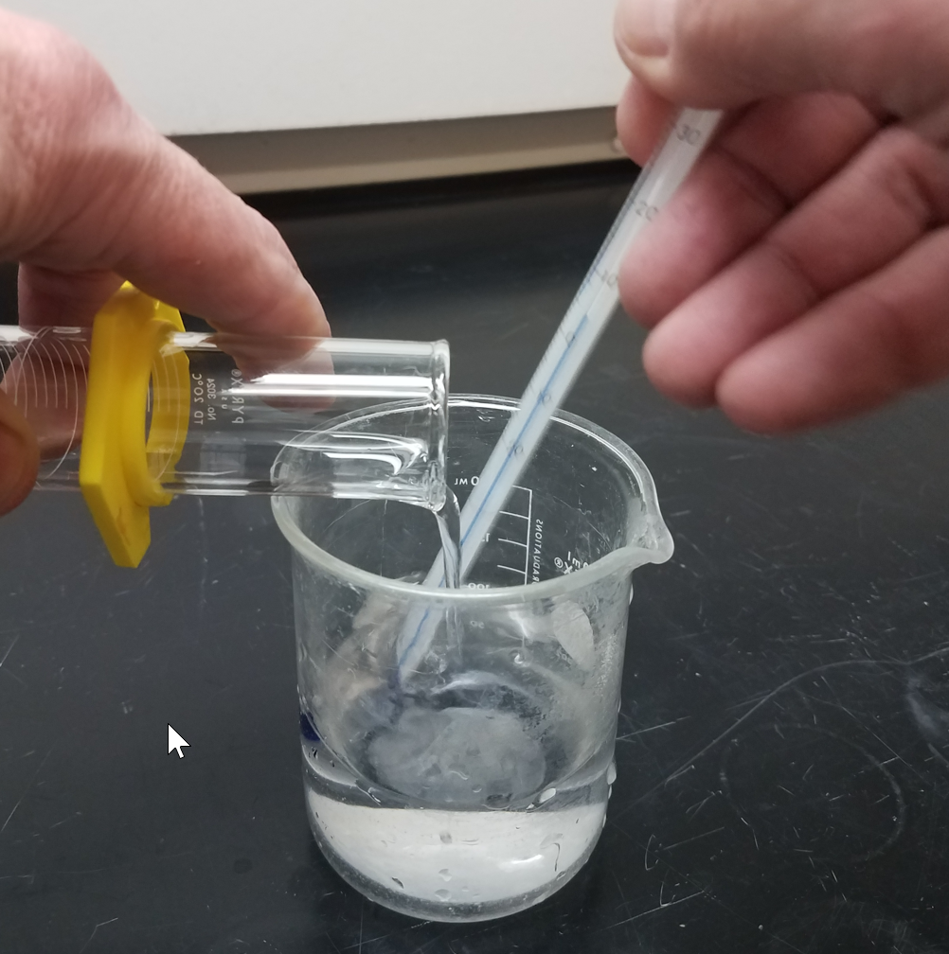
- Continue working in the fume hood as you slowly pour approximately 20 mL of 9 M H₂SO₄ into the beaker containing the filtered liquid while carefully stirring with the thermometer.

- Record the final temperature reached on your data sheet.

- Construct an ice bath from a 600 mL beaker by first filling it ¾ full with ice and then adding small amounts of TAP water (not distilled) to cover the ice.
A properly constructed ice bath should be mostly ice with just enough TAP water
to cover and improve contact with the beaker and the contents being cooled.

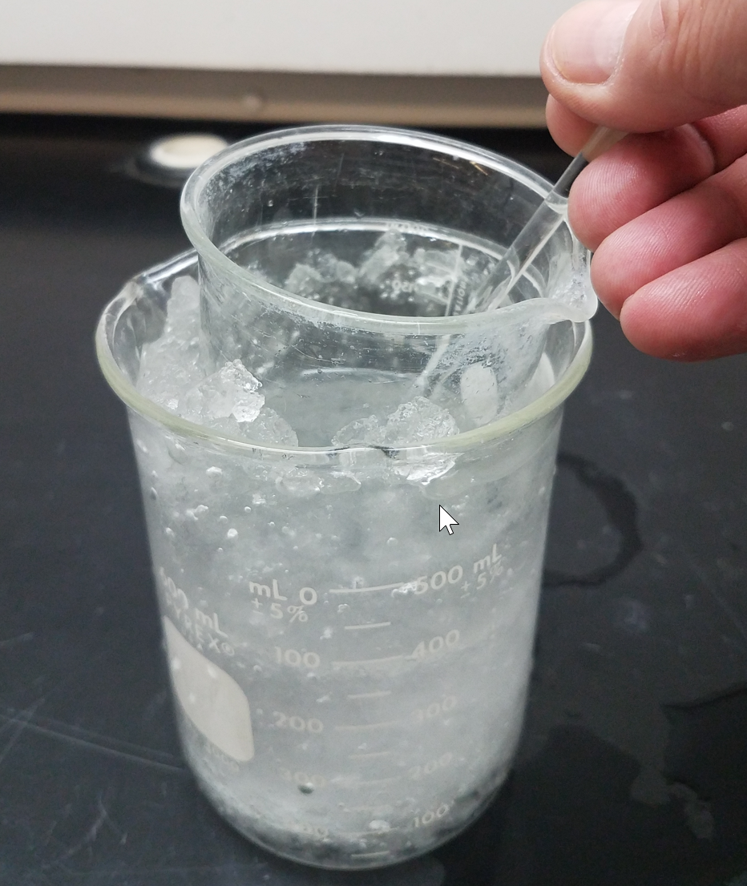
- Place the 250 mL beaker in the ice bath and use a glass stirring rod to vigorously stir the mixture.

- Rub/scrape the sides of the beaker with a stirring rod to accelerate the formation of product crystals.
- Cool for at least 10 minutes and when no further changes are observed measure the mixture’s temperature and record it as the “Recrystallization Temperature” with one decimal place accuracy.

Procedure 4: Vacuum Filtration
of Alum Product

- Obtain a piece of vacuum filter paper.
- Weigh the watch glass and vacuum filter paper on the analytical balance. Record the masses in your data table.
- The vacuum filtration apparatus will be set-up for you in the lab. Check to make sure the filter flask is secure in the clamp before proceeding.
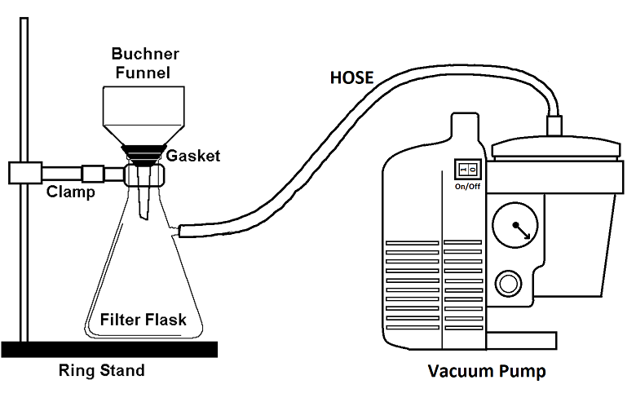
- Place the pre-weighed filter paper in the Buchner funnel.
- Use a small amount of water to wet the filter paper. This will “stick” the filter paper and keep it in place during the initial filtering stages.
- Turn on the vacuum pump.
- Remove the 250 mL beaker from the ice bath and swirl the contents to suspend the solid alum crystals in the liquid.

- Quickly pour the 250 mL beaker’s contents into the Buchner funnel.
- Rinse any remaining alum from the beaker into the Buchner funnel using ice cold distilled water.
- Continue filtering while you wash the alum product with small amounts of ice cold distilled water.
You may turn off the vacuum pump briefly to let the alum crystals momentarily bathe in the cold water before re-applying suction.
- Continue running the vacuum pump for 2 minutes to remove as much liquid from the alum as possible.
- Carefully remove the Buchner funnel from the Filter Flask. Use a metal spatula to transfer the alum and filter paper from the funnel onto the pre-weighed watch glass.
- Write your name and lab section number on a small piece of paper.
- Place your watch glass and alum on the tray provided by your instructor. Slip the name tag you just created between the filter paper and watch glass. This will let you easily identify your alum from others when you return to lab later.
- You will weigh your watch glass, filter paper, and dry alum when you return to lab. At that time you’ll be able to finish your calculations.

Procedure 5: Acid Neutralization
Procedure and Disposal

- Empty the filter flask into a 100 mL graduated cylinder.
- Record the volume of this liquid (Recorded filtrate volume) on your data sheet.
- Transfer the liquid from the graduated cylinder to your empty 600 mL beaker.
- Place the beaker in the bottom of a sink and neutralize the contents by adding scoops of solid sodium bicarbonate (NaHCO₃) to the solution while stirring with a glass stirring rod.
- When additional NaHCO₃ no longer produces effervescence (fizzing), you can flush the beaker’s contents down the drain with tap water.
Procedure 6: Cleanup

- All glassware should be thoroughly washed and then rinsed with a small amount of distilled water. Leave the clean glassware on a dry paper towel at your bench top.

- Clean the Buchner funnel and filter flask by rinsing them carefully with tap water followed by a small amount of distilled water.
- Place the Buchner funnels upside down near each filter station.
- Wipe down your laboratory spaces (benchtop and hood) with a damp sponge.
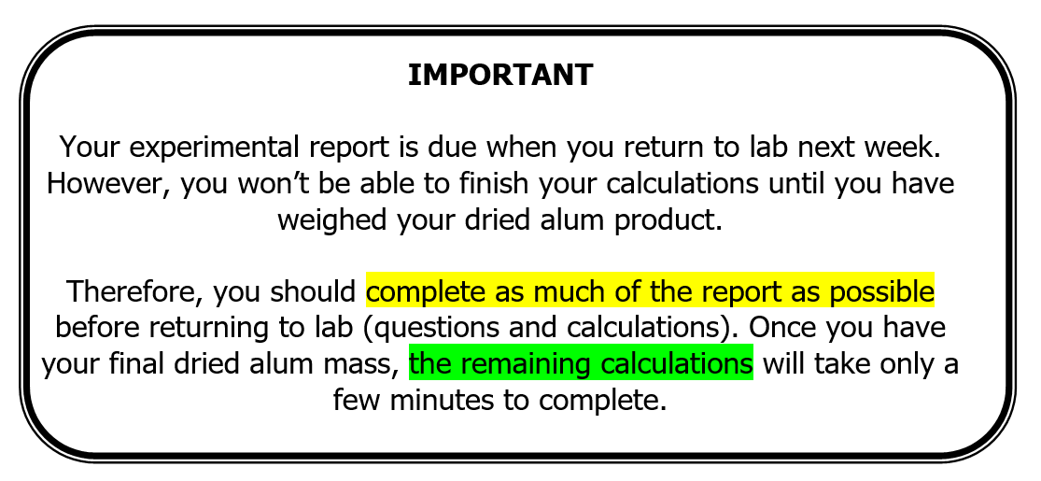

Alum: Measurements
250 mL Beaker mass
250 mL Beaker + aluminum mass
Temperature before & after adding H₂SO₄ | ^{Before / After}  /
Recrystallization temperature
Recovered filtrate volume
Filter paper mass
Watch glass mass
Final filter paper, watch glass & dry alum mass
(Measured next week in lab)

