C1151 Data Sheet Name_________________________
Calorimetry v1.22 Date of Exp. ________________
Lab Section ________________

Procedure 1  _{Det. of Calorimeter Constant} | _{Trial 1} | _{Trial 2}
Mass_{calorimeter} (empty)
Mass_{calorimeter} (+H₂O)
H₂O
Mass
T_{i}
T_{f}
ΔT
c | 4.184 J/gºC | 4.184 J/gºC
q
Cu
Mass
T_{i}
T_{f}
ΔT
c | 0.385 J/gºC | 0.385 J/gºC
q
Calorimeter
q
ΔT
C
C_{average}
Excess Sig. Figs.

Procedure 2  Determination of an unkknown metal’s specific heat | _{Trial 1} | _{Trial 2}
Mass_{calorimeter} (empty)
Mass_{calorimeter} (+H₂O)
H₂O
Mass
T_{i}
T_{f}
ΔT
c | 4.184 J/gºC | 4.184 J/gºC
q
Calorimeter
ΔT
C
q
Mystery Metal
Mass
T_{i}
T_{f}
ΔT
q
c
c_{average}

Procedure 3  _{Determination of ΔHrxn} | _{Trial 1} | _{Trial 2}
Mass_{calorimeter} (empty)
Mass_{calorimeter}
(+ combined solutions)
Solution_{combined}
Mass_{combined solutions}
T_{i}
T_{f}
ΔT
c | 4.184 J/gºC | 4.184 J/gºC
q
Calorimeter
ΔT
C
q
Reaction
q_{total}
HCl: Concentration
HCl: Volume
HCl: Moles
ΔH_{reaction} (kJ/mole)
NaOH: Concentration
NaOH: Volume
NaOH: Moles
ΔH_{reaction} (kJ/mole)

Procedure 1 SHOW ALL WORK AND REPORT RESULTS IN TABLES ABOVE

Calculate for each trial:
- calorimeter H₂O mass
- H₂O ΔT
- H₂O total heat q = m c ΔT
- Cu ΔT
- Cu total heat q = m c ΔT
- calorimeter q: - q_{Cu} = q_{H2O} + q_{calorimeter}
- calorimeter constant: C = q_{calorimeter}/ ΔT
- average calorimeter constant

Procedure 2 SHOW ALL WORK AND REPORT RESULTS IN TABLES ABOVE

Calculate for each trial:
- calorimeter H₂O mass
- H₂O ΔT
- H₂O total heat q = m c ΔT
- calorimeter: q (use average calorimeter constant)
- Metal: - q_{metal} = q_{H2O} + q_{calorimeter}
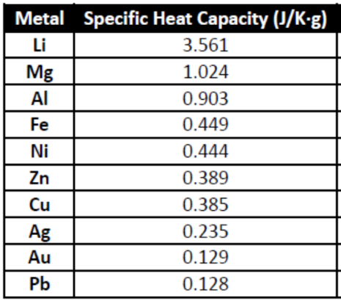
- Metal: Specific heat
- Identity of metal: Use your average specific heat value
to identify your mystery metal (Circle)

Procedure 3 SHOW ALL WORK AND REPORT RESULTS IN TABLES ABOVE

Calculate for each trial:
- calorimeter TOTAL combined solution mass
- Solution ΔT
- Solution total heat q = m c ΔT (use water’s specific heat)
- calorimeter: q (use average calorimeter constant)
- Reaction: - q_{reaction} = q_{solution} + q_{calorimeter}
- Reaction: moles of HCl
- Reaction: ΔH_{reaction} = q_{reaction}/mol_{HCl}
- Reaction: moles of NaOH
- Reaction: ΔH_{reaction} = q_{reaction}/mol_{NaOH}

Problem: 55.0 mL of 1.0 M HCl is mixed with 67.0 mL of 1.25 M NaOH.

The initial temperatures of the two solutions is 22.8ºC
Use your value of ΔH_{rxn} to determine the final temperature of the combined solutions.

Step 1: Determine the moles of HCl and NaOH present and clearly identify the limiting reactant.

Step 2: Use the limiting reactant and your ΔH_{rxn} value to determine the heat released by the reaction.

Step 3: Use the heat you determined in Step 2 to calculate the temperature change using
the equation: - q_{rxn} = m_{solution} × C_{solution} × ΔT + C_{cal} × ΔT.

Assume the solution has the same density and specific heat as pure water.

Step 4: Assuming the initial temperature of the two solutions is 22.8 ºC, determine the
final temperature of the total solution.

