Graphical Analysis Report
Name _________________________
Version 10.22 Date of Exp. ________________
Lab Section ________________

Ball # | Mass (g) | Diameter (cm) | Volume (cm³) | Density (g/cm³)  Correct Sig Figs!
Ball #1
Ball #2
Ball #3
Ball #4
Ball #5
Ball #6
Ball #7
Unknown Ball #1
Unknown Ball #2
Unknown Ball #3

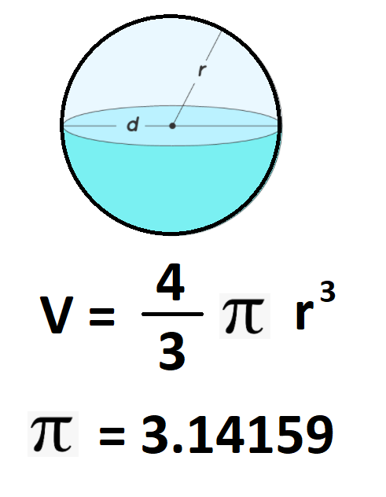
1. Calculate the volume of ball bearings 1 – 7 and record the result with excess significant
figures in the table above.
Show one example calculation below.

2. Calculate the density of ball bearings 1 – 7 and record the result with the correct number of significant figures in the table above. Show one example calculation below. (D=mass/Volume)

3. Using your results calculate the average density of the steel ball bearings. Use the internet to find the
density of steel from two different sources.
- URL₁: ________________________________________ Density₁: ___________________________
- URL₂: ________________________________________ Density₂: ___________________________

4. What is an “alloy” and how does this explain different reported steel densities?

_______________________________________________________________________________________
_______________________________________________________________________________________

5. Referring to your best straight line graph, what are the units of the slope? ________________________
What physical property of steel is the slope of this line related to? ________________________

6. Use the graphed data and your best trendline equation to predict the diameters of the three unknown ball bearings.
Show your calculations below and report your three results in the data table above with 2 decimal place accuracy.

7. How could we improve the accuracy of the largest unknown ball bearing’s diameter prediction?

_______________________________________________________________________________________
_______________________________________________________________________________________
_______________________________________________________________________________________

Insert your six graphs with trendlines and R² values below in order from best to worst trendline fit
Clearly identify which graph was “BEST” for our purposes in this lab.

