C1151 Data Sheet Name_________________________
Synthesis of Alum v1.22 Date of Exp. ________________
Lab Section ________________

Data Table | Measurements (units)
250 mL Beaker mass
250 mL Beaker + aluminum mass
Temperature before & after adding H₂SO₄ | ^{Before / After}  /
Recrystallization temperature
Recovered filtrate volume
Filter paper mass
Watch glass mass
Final filter paper, watch glass & dry alum mass
(Measured when you return to lab)
Alum mass
Aluminum mass
Aluminum moles | _{Excess Significant Figures}
Theoretical alum moles | _{Excess Significant Figures}
Molar Mass for AlK(SO₄)₂•12H₂O | _{Excess Significant Figures}
Theoretical alum mass | _{Excess Significant Figures}
Alum percent yield before filtrate adjustment  (See question 3) | _{CORRECT Significant Figures}
Alum percent yield after filtrate adjustment  (See questions 4c) | _{CORRECT Significant Figures}

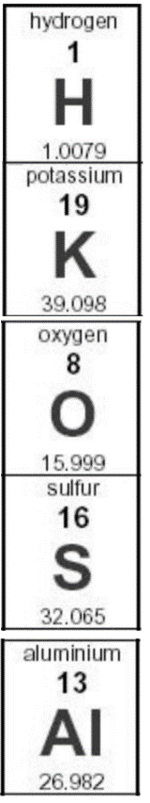
Questions: All SHADED questions below should be answered before the next time lab meets.
The other questions you’ll answer once you’ve measured the mass of dry alum.

- Is the reaction involving the addition of sulfuric acid an exothermic or endothermic reaction? Why?

- Use the initial aluminum mass to determine the theoretical alum yield in the space below. Note that the mole ratio for aluminum/alum is 1:1. Neatly show all work below and record this result with excess significant figures in the data table on page 1.

- Determine the percent yield for alum in the space below. Neatly show all work and record this result with the correct number of significant figures in the data table on page 1.

- Although most of the alum you produced was recovered on the filter paper, some amount of alum remained dissolved, passed through the filter paper and is now un-weighable.
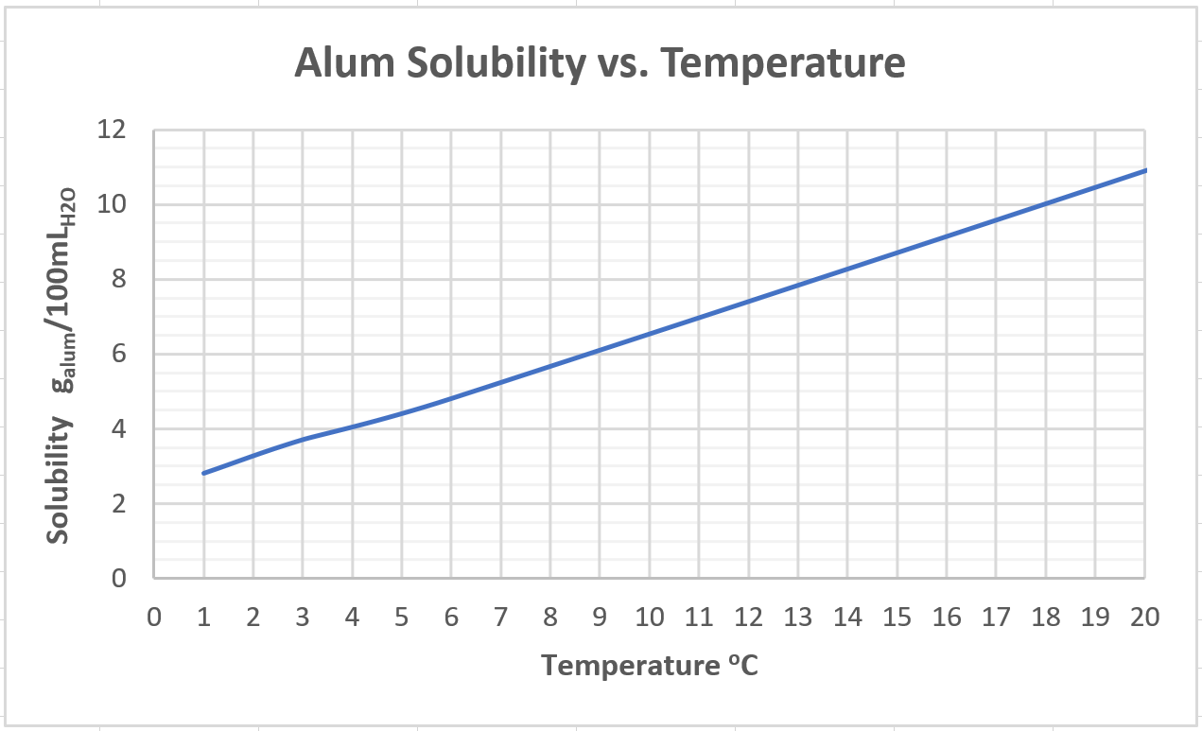

  - Reposition (click and drag) the horizontal and vertical lines above to determine the alum solubility at your recrystallization temperature. Read the solubility off the graph to one decimal digit and report it below with the correct units.
  - The graphical result from part “a” is the mass of alum dissolved in 100 mL of water at the filtrate temperature. Use a “proportion” and your filtrate volume to determine the amount of alum dissolved in this experiment. Neatly show your work below.
  - Add the dissolved alum mass to the actual product weight and use this value to recalculate the percent yield (Show calculations) based upon this higher value. Report the result on the data table with the correct number of significant figures.

- Consider the following problem:
“Examine the unbalanced chemical reaction shown below.
If 12.5 grams of propane (C₃H₈) are reacted/burned with oxygen gas, what is the mass of H₂O produced?
If 22.1 grams of H₂O are actually collected, what is the percent yield?”
C₃H_{8(g)} + O_{2(g)} → CO_{2(g)} + H₂O_{(g)}

  - List the steps you’ll take to solve this problem.
  - Determine the theoretical, actual and percent yields. (Show your dimensional analysis work)
  - Does the percent yield make sense? Why or why not?

