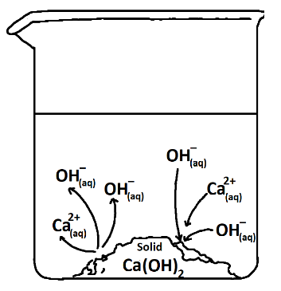
Determination of Calcium Hydroxide K_{sp}
Principles of Chemistry 2
Minneapolis Community and Technical College
v.3.22

Prelab questions
- Why is the name for Ca(OH)₂ “calcium hydroxide” and not “calcium (II) hydroxide”?
- Calculate the molar mass of iron (III) hydroxide.
- What are the molar and gram solubilities for iron (III) hydroxide in distilled water? (K_{sp} = 2.79 x 10⁻³⁹)
- Write out the solubility equilibrium chemical equation for nickel (II) phosphate.
- What is a common ion and why is the solubility of a salt always greater in distilled water than in a solution containing a common ion?
- In most situations, a known volume of Ca(OH)₂ would be titrated with HCl. However, in this case, HCl is titrated with Ca(OH)₂. Why?
- The salt XY₃ is dissolved in distilled water. If the concentration of the X³⁺ ion is found to be 1.44 x 10⁻⁴ M, what is the concentration of the Y⁻ ion AND what is the value for K_{sp} for this salt?
- In your own words, describe the process illustrated in the figure above (RH corner).
Solid/Aqueous Equilibrium
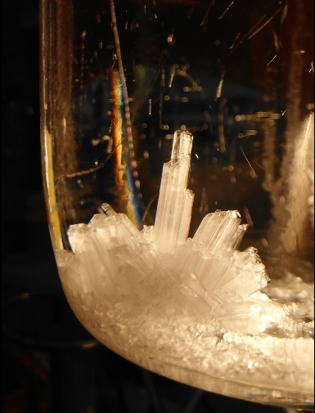
When a solute is placed in a solvent, the solute dissolves. In some cases like NaCl and water, we say the solute is “soluble” meaning that a lot of the solute will dissolve. In other cases like PbCl₂ and water, the amount of solute that dissolves is slight where we refer to the solute as visibly insoluble or “sparingly soluble.”
When additional solute can dissolve in a solution, it is unsaturated. When the maximum amount of solute has dissolved, we say the solution is saturated. A solution can be supersaturated if first heated and then allowed to slowly cool. However, this situation isn’t stable and will revert back to the saturated state if disturbed.
A saturated solution can be easily identified by the presence of solute at the bottom of the container that won’t dissolve. This solid solute is equilibrium with the dissolved solute. Thus, on an atomic scale, there’s a lot going on as the solid dissolves and reforms at the same rate. Equilibrium continually tears down and rebuilds the solid solute over time and if left for a very long time, the shape of the solid solute crystals will change even though their total mass remains constant.
If we consider the PbCl_{2(s)}/H₂O system, this equilibrium can be represented chemically as follows:

PbCl_{2(s)} ⇌ Pb²⁺_{(aq)} + 2 Cl⁻_{(aq)}

where the forward reaction is the dissociation of solid lead (II) chloride into its respective ions. The reverse reaction demonstrates the recombination of aqueous ions as they reform the solid. When the rates of these two competing processes are equal, we have the equilibrium situation observed in saturated solutions.
Another detail worth noting is that since the salt is a 1:2 salt, the concentration of chloride ions is twice that of the lead ion concentration. This thinking is valid as long as the salt is dissolving in distilled water that is initially free of either ion.
The law of mass action (LMA) for such equilibria is simple owing to the solid that appears as the only reactant. In the case of lead (II) chloride, the LMA is as follows:
[Pb²⁺] × [Cl⁻]² = K_{sp}
where K_{sp} is the “solubility product” equilibrium constant which for PbCl₂ equals 1.17 x 10⁻⁵.
What this means is simple: For any saturated lead (II) chloride solution, the product of the lead ion concentration times the chloride ion concentration squared, must equal 1.17 x 10⁻⁵.
Solving Solubility Equilibrium Problems
The simplest solubility equilibrium situation is that of a solute dissolving in pure water. In this case the I.C.E. problem solving structure looks like:
PbCl_{2(s)} ⇌ Pb²⁺_{(aq)} + 2 Cl⁻_{(aq)} K_{sp} = 1.17 x 10⁻⁵
I ~ 0.0 M 0.0 M
C ~ +S +2S
E ~ S 2S
Although any variable could be used (“x” for example), the letter “S” is often used in solubility equilibrium problems where it represents the molar solubility of the salt in units of M/L.
Substituting the equilibrium expressions into the LMA expression on the previous page we have:
[Pb²⁺] × [Cl⁻]² = S × (2S)² = 1.17 x 10⁻⁵
from which we determine that
S = 1.43 x 10⁻² M
This value, known as the molar solubility of lead (II) chloride in pure water, is also the concentration of Pb²⁺ ions in the saturated solution. The chloride ion concentration is twice this value: 2.86 x 10⁻² M.
The gram solubility is calculated by multiplying the molar solubility by the molar mass for lead (II) chloride (278.1 g/mol):
Gram Solubility = 1.43 x 10⁻² mol/L × 278.1 g/mol = 3.98 g/L
Another twist to this type of problem is when the solid solute is not added to distilled water, but instead to a solution that already contains common ions. The fact that there are already ions present in the solution means that the solute won’t have to dissociate as much to reach equilibrium. Thus, the solubility of a solute in a solution is always less than the solubility in pure water.
Consider the following problem: Calculate the molar and gram solubility of lead (II) chloride in a 0.75 M KCl solution. Because the solution already contains the chloride ion, less PbCl₂ will have to dissolve to reach equilibrium. We solve the problem as we did above but recognize the initial 0.750 M chloride ion concentration. (K⁺ is a spectator and not part of this problem’s solution).
PbCl_{2(s)} ⇌ Pb²⁺_{(aq)} + 2 Cl⁻_{(aq)} K_{sp} = 1.17 x 10⁻⁵
I ~ 0.0 M 0.750 M
C ~ +S +2S
E ~ S 0.750 + 2S
Substituting the equilibrium expressions into the LMA expression above we have:
[Pb²⁺] × [Cl⁻]² = S × (0.750 + 2S)² = 1.17 x 10⁻⁵

Assuming 2S is much less than 0.75 we determine:
Molar Solubility = S = 2.08 x 10⁻⁵ M
Gram Solubility = 278.1 × S = 0.00578 g/L
Note that as initially predicted, the amount of lead (II) chloride that dissolves in 0.75 M KCl is MUCH less than in pure distilled water. In this case, the difference is almost 700X times less!

Determination of K_{sp} for Calcium Hydroxide

Calcium hydroxide, Ca(OH)₂, is a sparingly soluble salt with K_{sp} = 4.68 × 10⁻⁶. Since both calcium hydroxide and lead (II) chloride are 1:2 salts, we can directly compare their respective K_{sp} values and conclude that calcium hydroxide is less soluble than lead PbCl₂ in distilled water.

In this activity, your goal is to experimentally determine K_{sp} for Ca(OH)₂. When an excess of solid calcium hydroxide is placed in pure water, the following equilibrium is achieved:

Ca(OH)_{2(s)} ⇌ Ca²⁺_{(aq)} + 2 OH⁻_{(aq)}

Once the equilibrium concentrations of Ca²⁺ and OH⁻ are determined, the value of K_{sp} is then calculated using the law of mass action:
[Ca²⁺] × [OH⁻]² = K_{sp}
where [Ca²⁺] = ½ [OH⁻] since pure water is the solvent.
Experimentally, we’ll use titration and a known concentration of hydrochloric acid to neutralize the OH⁻ and determine its concentration.

Procedure:
  - Locate the bottle of unfiltered Ca(OH)₂ at your lab station and measure its temperature with the thermometer provided.
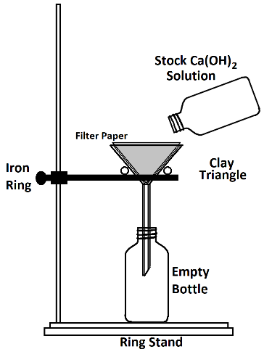
  - Set up a gravity filtration apparatus and filter
all of the Ca(OH)₂ solution in the 100 mL bottle provided.
  - Keep the bottles capped at all times to
minimize the formation of calcium carbonate (Chalk) that occurs when the solution is exposed to CO₂ in the air:
Ca(OH)_{2(s)} + CO_{2(g)} → CaCO_{3(s)} + H₂O_{(l)}

  - Rinse the burette two times with a few mL of
the filtered Ca(OH)₂ solution.
  - Overfill the burette with Ca(OH)₂ solution, open the stopcock and flush the air bubbles out of the burette tip.
  - Record the initial Ca(OH)₂ level of the burette.
  - Repeat the above procedure for the HCl burette.

  - Measure between 15 and 20 mL of HCl into a clean 125 mL Erlenmeyer flask. Record the final volume of the burette and calculate the volume of dispensed HCl with two decimal places.
  - Add two drops of phenolphthalein indicator solution, 25 mL of distilled water and a magnetic stir bar to the Erlenmeyer flask.
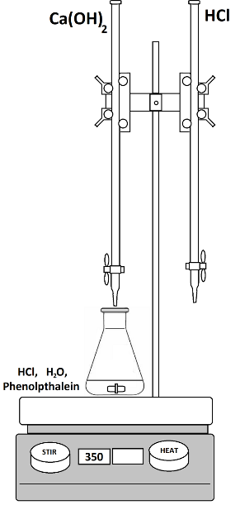
  - Place the flask on the stir plate and begin stirring (~300 rpm, no heat)

  - Slowly add Ca(OH)₂ solution to the solution in the Erlenmeyer flask noting the appearance of the pink color changes.
  - As you approach the titration’s equivalence point, the pink color will become more persistent. Slow down and stop when the equivalence point is reached (color change lasts for 20 seconds or more).
  - Record the Ca(OH)₂ burette level and calculate the volume of Ca(OH)₂ required to reach the equivalence point.
  - Repeat this experiment two more times for a total of three trials.
  - Prepare a data table of your results, including the initial, final and total volumes of HCl and Ca(OH)₂ used for each titration.
Data Table:
 | Trial 1 | Trial 2 | Trial 3
Temperature
Volume Ca(OH)₂ initial
Volume Ca(OH)₂ final
Volume Ca(OH)₂ NET
Volume HCl initial
Volume HCl final
Volume HCl NET
Concentration HCl
moles_{HCl}
Concentration OH⁻
Concentration Ca²⁺
Experimental K_{sp}
Average Experimental K_{sp}
K_{sp} Δ%

Lab Report
Page 1
- Upper right hand corner: Name, Lab Section and date-of-experiment
- Completed data table (above)
Page 2
Answers to the following questions:
- Why does K_{sp} increase at higher temperatures for most sparingly soluble salts?
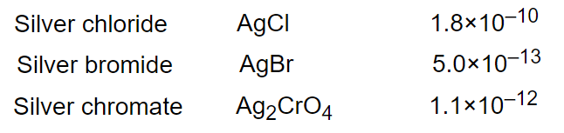
- Determine the molar solubilities for the three salts listed at right and put them in order from least soluble to most soluble.
When can/can’t you use K_{sp} values alone to order salt solubilities?

- The filtration part of this experiment has in the past been problematic.
Not filtering out all of the solid Ca(OH)₂ before doing the titration leads to incorrect K_{sp} values.
Describe why and how unfiltered calcium hydroxide, present during the titration, will affect the calculated K_{sp} value.

Page 3
- Representative calculations for experimental Ksp calculations
- Calculations for question 2 (above)

