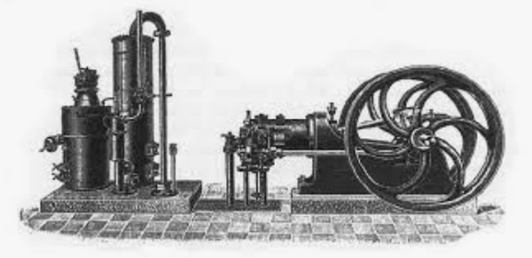
Heat Engines and the Dunking Bird
Principles of Chemistry 2
Minneapolis Community and Tech College
v.2.24
Prelab questions.
1. What is an engine’s “Working Substance?”
2. Calculate the ideal efficiency of a heat engine operating between 100ºC and 0ºC.
3. How can an engine’s theoretical efficiency be increased?
4. Why are gases better than solids at performing heat → work conversions?
5. What’s the main difference between an internal combustion engine (ICE) and an external combustion engine (ECE)?
6. Why can’t the evaporative cooling experiments in today’s activities be done in the hood?
7. Calculate the total amount of energy present in 15 gallons of gasoline.
Gasoline : 45 MJ/kg D_{gasoline} = 0.7429 g/mL 1 gallon = 3.78541 Liters
8. In the example above, approximately how much of the original fuel’s energy would be wasted as heat?
9. The waste heat in the above example warms the surroundings and increases the entropy.
Calculate the surrounding’s entropy increase assuming the temperature of the surroundings is 0ºC.
10. What does it mean to be “powerful” in the scientific sense?
11. What is a “tachometer” ?
12. How does the Stirling Engine in this experiment move gas from high temperature to low temperature?
13. Which piston in a Stirling Engine pushes and pulls the engine’s flywheel around?
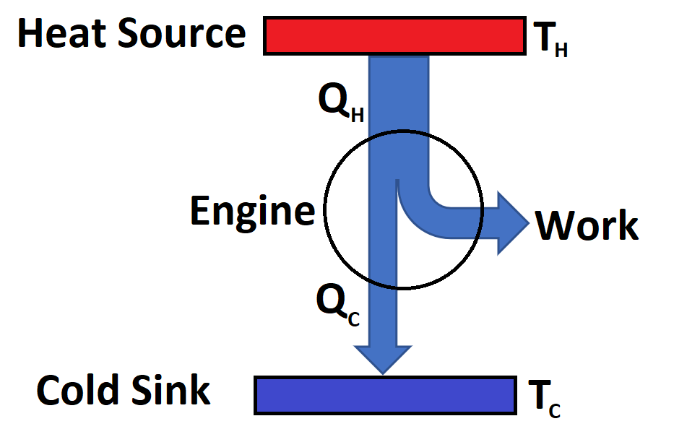
Introduction
Heat engines are devices that convert heat flow into useful work. As shown in the diagram at right, heat spontaneously flows from high temperature (T_{H}) to low temperature (T_{C}).
The heat engine (circle) converts some of the original heat flow (Q_{H}) into work. The remaining heat energy, Q_{C} continues flowing into the Cold Sink (often the surroundings) at temperature T_{c}. Since energy is always conserved, we have:
Q_{H} = Q_{C} + Work
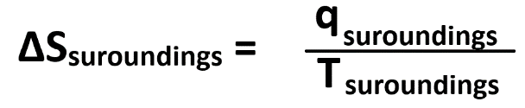
Q_{C} can be considered “waste heat.” That is, heat that isn’t converted into work but instead warms the surroundings. Obviously, it’s best to minimize the wasted heat as doing so would allow for the maximum amount of work to be done. However, zero waste heat is impossible and is in fact required to make the process spontaneous. The entropy change (S) experienced by the surroundings is given by:

Since engines release heat (negative) into the surroundings which subsequently gain heat (positive), the surroundings experience an increase in entropy which is a factor in favor of a spontaneous process.
Engine examples include Internal Combustion Engines (ICE) found in motor vehicles, external combustion engines (Steam and Sterling engines) and turbine engines (aircraft). In all cases, a fuel is burned to create a temperature difference, heat flow and work. The engines also utilize a working substance (usually a gas) that expands and contracts with differences in temperature.
Efficiency
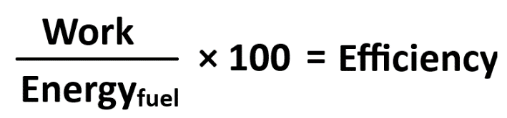
The efficiency of an engine is a comparison of the work it actually does to the total energy available in the fuel:
Surprisingly, ICE’s typically operate at only 25 – 35% efficiency. This means that 65 – 75% of the energy available in the fuel is completely wasted as heat energy that escapes into the surroundings. Said another way, for every dollar the consumer puts into their car’s gas tank, 65 – 75 cents is wasted in heating up the environment. On the upside, here in Minnesota, we do utilize a small amount of this wasted heat energy warming up the interior of our automobiles in the winter to keep ourselves warm.
Other ICE technologies do better. Diesel engines are more efficient and operate in the 40 – 50% efficiency range. Gas turbines (aircraft engines) are slightly more efficient than Diesel. It’s also interesting to note that the electric motors in EV’s are typically 50% efficient and consequently waste approximately half of the battery’s energy as heat.
Although one might think that improving engine efficiency is just a matter of better construction and engineering, there is a theoretical limit to engine efficiency determined via thermodynamic principles. This ideal limit is obtained via the Carnot cycle (Sadi Carnot 1796 – 1832) which assumes the engine to be frictionless and reversible ways. The result, given below, shows how the best efficiency depends only on the two operational temperature extremes T_{cold} and T_{hot} (Kelvins).
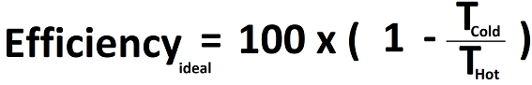

The energy not transformed into work is lost as heat energy that warms the environment and increases its entropy.
For example, if the combustion temperature of an ICE is 1400 ºC (1673 K) and the outside air temperature is 25 ºC (298 K), the best possible efficiency for the engine is determined to be 82 %. This is the best result that could be attained by the internal combustion engine operating between these two temperatures. Frictional is the main reason for the much lower actual efficiencies observed in real life.

Power and Energy (Click for video link)
Energy (Joules) is defined as the capacity to do work. For example, the single slice peanut butter toast breakfast supplies us with 267 Calories or approximately 1000 kJ of potential energy that fuels our biological machinery during the day.
Now consider two different people; the first a practiced runner in excellent physical shape and the second a middle aged professor in adequate physical condition (considering his age).
Both runners are asked to run up a long hill that is just high enough to be equivalent to one piece of peanut butter toast. That is, at the end of the event, both runners will have consumed exactly the same amount of energy, 1000 kJ.
The first runner accomplishes the task in 60 minutes while the second runner requires 120 minutes. Why? Well, the runner is in better physical condition meaning their muscles are capable of moving legs and arms faster thus achieving greater speed. The professor’s muscles are not capable of moving as fast and he moves more slowly and less powerfully.
This example illustrates the difference in power output of the two individuals. The runner’s “machinery” is more powerful since it can convert energy into motion more quickly. The professor’s power output is smaller as he requires more time to climb the same hill. But at the end of the race, both consume the same amount of peanut butter toast.
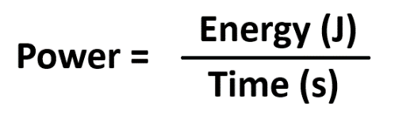
We define power as follows:

The units of power are Joules/sec otherwise known as Watts where 1 W = 1 J/s
If we use the information above to calculate the power output of the runner and now exhausted professor, we find:
Power_{runner} = 278 W = 0.37 horsepower and Power_{professor} = 139 W = 0.19 horsepower
That the runner is twice as powerful as the professor makes sense since it took the professor twice as long to complete the hill climb as the runner.
Moral to the story: A more powerful engine does work more quickly than a less powerful engine on the same amount of fuel.

Stirling Engine (Click for video link)
For example, consider the external combustion engine known as the Stirling engine. Shown below, it consists of a trapped gas that can be moved around by the Gas Displacement Piston. With the Gas Displacement Piston in the lower position (Figure below left), the trapped gas is forced into contact with the upper cold plate (blue). Most importantly, now that the gas is cooled, it contracts and in response the “Power Piston” is pulled downward. Similarly, when the Gas Displacement Piston is in its upper position (Figure below right), the trapped gas is forced into contact with the hot lower plate that’s heated externally. In response, the gas expands and the “Power Piston” is pushed upwards.
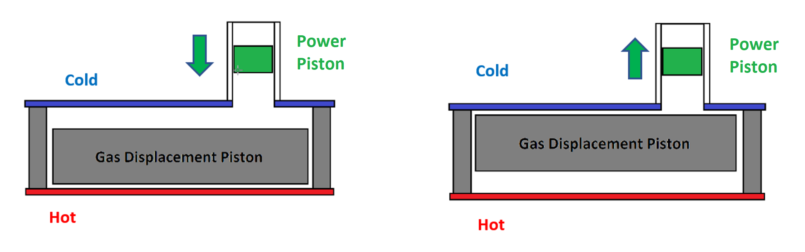
Note that the Power Piston rises or falls depending on whether the trapped gas expands …(hot) or contracts (cold).
Clever engineering connects the Power Piston to a rotating wheel. When the Power Piston moves upwards in response to gas expansion, the flywheel rotates. Likewise, when the gas cools, the Power Piston moves downwards which continues the circular movement of the flywheel.
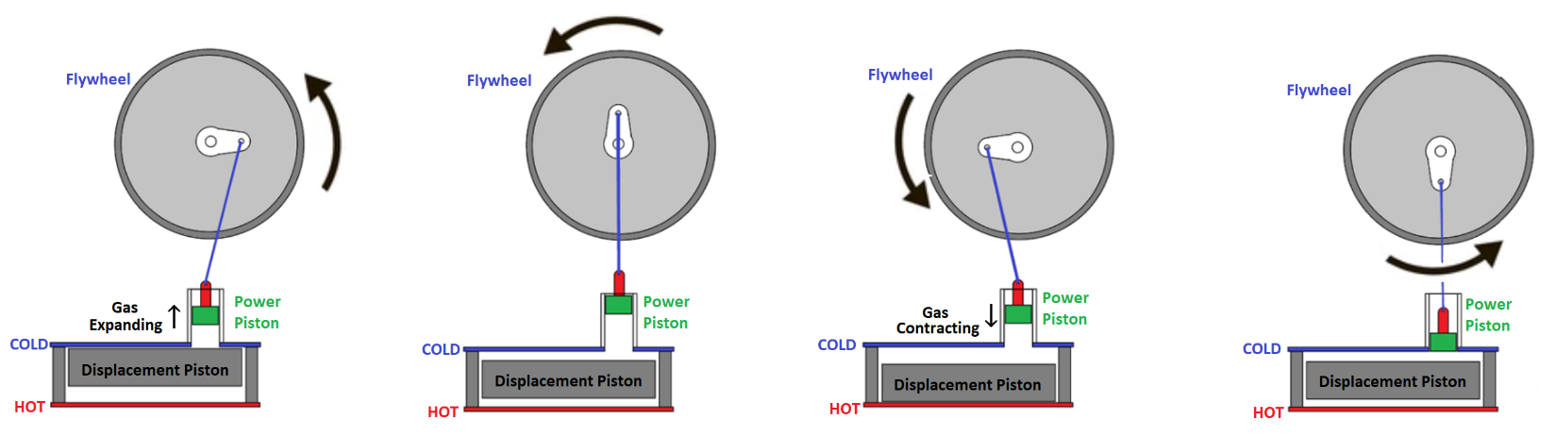
Additionally, a rod that connects the Gas Displacement Piston and flywheel (not shown above) moves the displacement piston at the exactly the right time to keep the flywheel turning continuously.
Laboratory Report:
Page 1: Data table: Use the format below to construct a data table for all 25 Stirling Engine data points.

# | Temp (ºC)  (upper plate) | Temp (ºC)  (lower plate) | ΔT (ºC) | Calculated Efficiency | Rotational  Speed (rpm)
1
2
3

Page 2: Graph: Construct a Rotational Speed vs. ΔT graph. Include an appropriate trendline analysis.
Page 3: Answer the following questions:
- Explain the dunking bird’s operation as if you were describing it to a non-science friend.
- Automobile engines spin at about 3500 rpm when cruising down the highway. Use your graph and trendline analysis to determine a ΔT value that would, in theory, spin your Stirling engine spin at that speed.
(Show all work and calculations).
- Describe how you could experimentally achieve the ΔT value determined in question #2. Include details as to what equipment you’d use and how you’d measure the required temperatures.
- What problems are you likely to encounter performing the experiment you described in Question #3?

Evaporative Cooling Comparisons
- Set up the Computer, Vernier LabQuest system and
temperature probe.
- Position the temperature probe in the articulated
arm assembly.
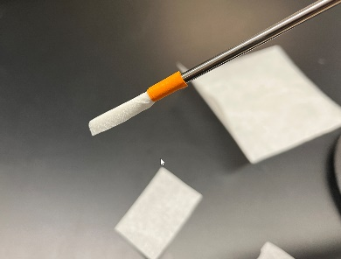
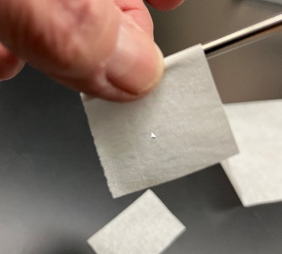
- Cut small sections of tissue and carefully wrap one of them
around the tip of the temperature probe.
- Use a small piece of tape to secure the tissue and keep it
from un-raveling. (orange tape above)
- Construct a protective screen from cardstock (stiff paper) and
use it to protect the temperature probe from room air drafts.
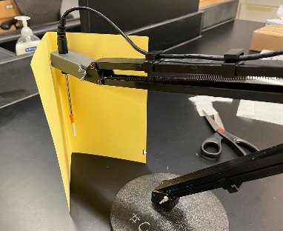
- Monitor probe’s temperature for several minutes and record
the average value (2 decimals). You will use this value in
future comparisons.
- Thoroughly wet the tissue with several drops of room
temperature distilled water and monitor the temperature
for several minutes. Record the lowest temperature observed
during this time.
- Re-wet the tissue with water if it has dried out. Remove the protective screen
and use the small electric fan to blow air at the temperature probe and
tissue. Record the lowest temperature reached.
- Repeat the above steps with new tissue and ethanol.
- Repeat the above steps with new tissue and methanol.

Dunking Bird Operation
The dunking bird is a heat engine that operates between two
temperatures and performs work.
Warning: Glass … Breakable!
1. While holding the bird vertically via the hat, warm the bird’s
bottom by placing it between your thumb and forefinger.
Report and record how the liquid moves in the bird.
A diagram should be used to record this and all information.
Perform the same experiment but this time warm the bird’s RED
head with your fingers. Record your observations.
2. While holding the bird vertically, cool the bird’s bottom with ice held in a paper towel.
Record your observations.
Repeat but this time cool the bird’s head with ice. Record your observations.
3. Thoroughly wet the bird’s absorbent RED head with distilled
water and observe the bird for several minutes.
a. Record the back-n-forth repetition rate in units
of dunks per second.
b. Aim a fan at the bird’s head from the side and
remeasure the dunk rate.
c. Dry the bird’s head (blot with paper towel) and re-wet
with ethanol. Record the repetition rate with and
without fan.
d. Dry the bird’s head and re-wet with methanol. Record
the repetition rate with and without fan.

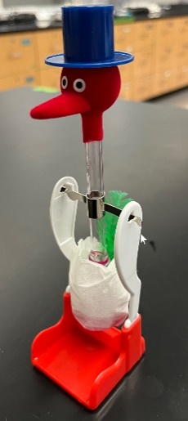
Diapered Dunking Bird Operation
Use a small piece of tissue and tape to create a diaper for
the bottom of the dunking bird.
Keep the additional weight to a minimum and be sure the
diaper doesn’t catch or rub on the bird stand
(i.e. the bird swings freely).
1. Wet both the bird’s head and
diaper with water.
Record your observations
2. Use a paper towel to remove as much water from
the head as possible.
Blot, don’t scrub.
Apply a small amount of methanol to the bird’s head and record your observations.

Dunking Bird and work
The dunking bird does very little work so let’s see if we can make it work a little harder.
Modify the dunking bird to lift or move a paperclip.
Record your method and outcomes in your notebook.

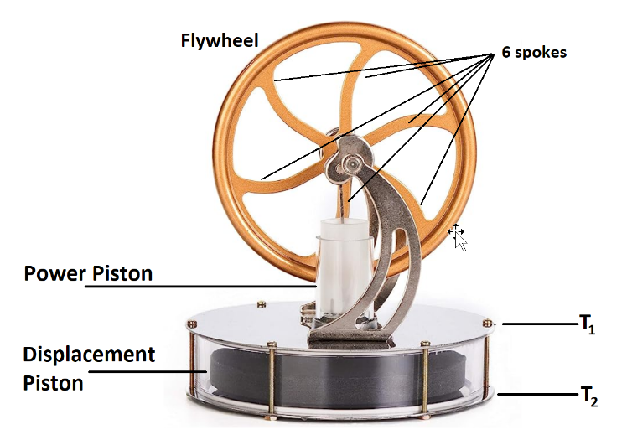
Stirling Engine

The Stirling engine above is fragile. Handle it carefully.
The engine operates when the metal plate T1 has a different temperature
than T2. The temperature difference creates a situation where work can
be done and this is observed as the flywheel spinning.
In normal use, the engine is placed on top of a cup containing a hot beverage.
The beverage heats the lower plate while the upper plate remains at room
temperature.
However, in this experiment, we’ll operate the Stirling engine with the
topmost plate at 0 ºC using crushed ice. Electrical tape, wrapped around
the engine’s top plate, keeps the ice and ice water from draining away.
It is important to replace ice as it melts to maintain the
desired 0 ºC temperature.
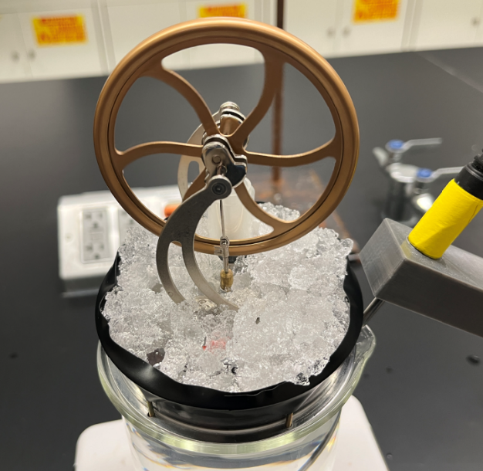

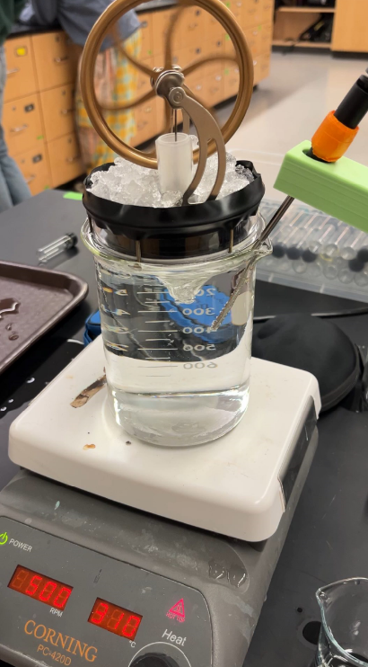
The lower plate is heated
with a water bath which
consists of a full 800 mL
beaker and stir rod. The
hotplate (T = 350 ºC Stir =
400 RPM) warms the water
from below and the magnetic
stir bar insures uniform water
temperature.
The 800 mL beaker needs to
be nearly full in order for us
to assume the lower plate is
at the same temperature as
the water.
The water temperature that
we’ll assume is equal to the
lower plate temperature is
measured using a
temperature probe and the
Vernier computer interface.
(Picture right).

Stirling Engine and Performance Measurements
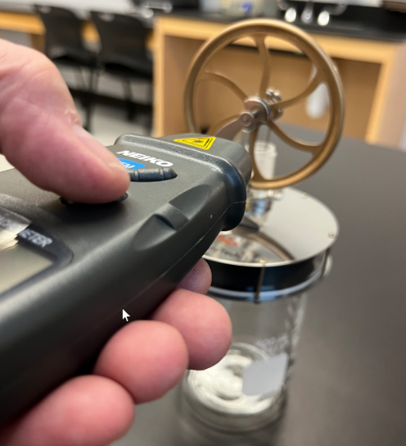

The flywheel’s rotational speed is measured in rpm (rounds per minute) and
we’ll measure this with a device called a tachometer (picture above).
The tachometer is pointed at the flywheel’s spokes while pressing
the “test” button. Aim the tachometer at the wheel’s spokes using its
red LED.
The rotational speed is displayed on the tachometer’s digital display.
However, since the flywheel has 6 spokes, the tachometer reading
must be divided by 6 for the actual rotational speed.
This rotational speed result is then recorded in your lab notebook.
Your goal in this activity is to measure the Stirling engine’s rotational
speed for 25 different temperatures between room temperature and 70 ºC. .

