Determination of the Heat of Solution: ΔH_{solution}
Minneapolis Community and Technical College
V.4.22

Heat of Solution
Solution formation occurs as a solute is dissolved in a solvent and is often modeled as a 3 step process:
- ΔH_{solute}: Break up the solute into individual atomic/molecular species
- ΔH_{solvent}: Create space between solvent species for the solute particles to later occupy
- ΔH_{mixing}: Allow the solute particles to move into the spaces created in between solvent species
Each step above either releases energy (exothermic) or absorbs energy (endothermic) and the overall heat of solution, ΔH_{solution}, is the total of all three steps:
ΔH_{solution} = ΔH_{solute} + ΔH_{solvent} + ΔH_{mixing}
For aqueous ionic solutions, we make the following replacements:
ΔH_{solute} = - ΔH_{lattice}
and
ΔH_{hydration} = ΔH_{solvent} + ΔH_{mixing}
to give

ΔH_{solution} = - ΔH_{lattice} + ΔH_{hydration}

The lattice energy, ΔH_{lattice} is a positive (endothermic) value that represents the energy required to overcome the electrostatic attractive forces within the crystaline lattice and tear it apart.
ΔH_{hydration} is the heat energy that is released as the free ions and solvent interact to create the solution. This latter step is releases heat energy and is exothermic (negative)
In today’s activies, you will use calorimetry to determine the ΔH_{solution} for a variety of different ionic solutes in water.

Introduction to Calorimetry
Constant pressure calorimetry is an experimental technique used to measure the heat released or consumed by a chemical reaction. It’s “constant pressure” because the entire experiment is done at atmospheric pressure. The action takes place in an insulated cup known as the calorimeter that’s insulated to keep the outside surroundings from affecting the results. A good calorimeter, like a YETI travel mug, is designed to keep hot things hot and cold things cold regardless of the outside temperature.

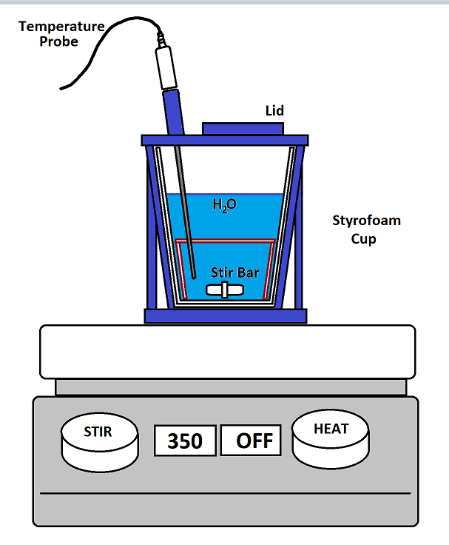
At right is a diagram of the calorimeter apparatus you’ll be using in this experiment. The key features are:
- Styrofoam coffee cup.
Styrofoam is a great insulator and is at the heart of this apparatus. The blue support structure protects the cup, supports the temperature probe and provides a lid that keeps heat from escaping out the top.
- H₂O (or some other solution):
The water or solution in the Styrofoam cup is what gains or loses heat energy as indicated by temperature increases or decreases respectively.
- Temperature probe.
The temperature probe monitors the temperature of the liquid in the calorimeter.
- Stir bar.
The stir bar mixes the contents of the calorimeter with the help of the stir plate below. This insures that the temperature measured by the temperature probe is the same for the solution everywhere.
Note that the stir plate “HEAT” function is turned off. This is necessary to keep from melting the apparatus.
- Lid
The lid is closed during the experiment to keep heat from moving in or out of the calorimeter.

Calculating heat transfer
In the experiments that follow, the water (or solution) gains heat energy and is calculated as follows:
q_{H2O} = m_{H2O} × c_{H2O} × ΔT_{H2O}
where q is the heat, m is the water’s mass in grams, c is water’s specific heat (4.184 J/gºC) and ΔT is the change in temperature (T_{f} – T_{i}). In experiments involving aqueous solutions, we’ll use water’s specific heat in these calculations.
However, while water gains heat energy, so does the calorimeter. Yes, we’ve designed the calorimeter to be as insulating as possible, but even so the cup, stir bar and temperature probe interact and lead to heat absorption.
We can calculate the amount of heat absorbed by the calorimeter as follows:
q_{calorimeter} = C_{calorimeter} × ΔT _{calorimeter}
where q is the heat absorbed by the calorimeter, C is the calorimeter constant (J/ºC) and ΔT is the change in temperature (T_{f} – T_{i}). Mass is not used in this calculation.
It’s important to note that the calorimeter constant must be determined experimentally and this is the purpose of procedure 1 where we use a known mass of hot copper metal to determine C.
Lastly, one can combine the two equations above to determine the total heat gained (or lost) during the process:
q_{total} = m_{H2O} × c_{H2O} × ΔT_{H2O} + C_{calorimeter} × ΔT _{calorimeter}
Since the calorimeter and water are in contact with one another their respective ΔT’s are the same.

Procedure 1
In procedure 1, we’ll prepare the calorimeter with room temperature distilled water and then add a copper cylinder that’s been heated up to 100ºC.
By measuring the final temperature, we’ll calculate the total heat released by the copper cylinder:
q_{Cu} = m_{Cu} × c_{Cu} × ΔT_{Cu} where c_{Cu} = 0.385 J/gºC
Now, the heat lost by the copper is gained by the water and calorimeter. However, a negative sign is required to make the mathematical signs work out. This equation is used to determine the calorimeter constant, C_{calorimeter}.

q_{total} = - q_{Cu}
…or…
m_{H2O} × c_{H2O} × ΔT_{H2O} + C_{calorimeter} × ΔT _{calorimeter} = - m_{Cu} × c_{Cu} × ΔT_{Cu}
Everything in this equation is either known or measured except for C_{calorimeter} which is calculated and used for all subsequent calorimeter trials. Typical values for C_{calorimeter} are in the range of 20 J/ºC - 50 J/ºC.

Procedure 2
In procedure 2, you will begin with 100 mL of room temperature distilled water in the calorimeter. You will then add two generaous scoops of the chosen solute. Temperatures will be monitored with a temperature sensor that will provide initial and final temperatures.
The total heat released or absorbed is determine via the following equation:
q_{total} = - (q_{solution} + q_{calorimeter})

q_{total} = - (m_{solution} × c_{H2O} × ΔT_{solution} + C_{calorimeter} × ΔT _{calorimeter} )
where we use the specific heat of water as an approximation for the solution.
ΔH_{solution} is calculated from q_{solution} by reporting it per mole of solute

ΔH_{solution} = q_{total}/mol_{solute}

Experimental Procedure 1:
Determination of the calorimeter constant
The purpose of this trial is to determine the calorimeter constant, C_{cal}, for your calorimeter. You will repeat this procedure twice, calculate the calorimeter constant for each trial, and then compute the average of the two calorimeter constants. This value will be used in Experiments 2 and 3 where we’ll need a value for the calorimeter constant to complete the calculations.
- ½ fill a 800 mL beaker with tap water. Sink a 50 mL beaker in the water and position it off to the side
- Add a large stir bar to the 800 mL beaker.
- Weigh the dry copper cylinder on a top loading balance and then place it in the submerged 50 mL beaker.
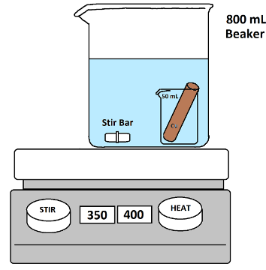
- Place the 800 mL beaker and its contents on a hot plate and heat strongly while stirring. We will need the water to boil.
- While heating the copper, weigh the dry/empty calorimeter on a top loading balance. Include the stir bar, lid and internal support in this measurement.
- Use a graduated cylinder to measure out 100 mL of room temperature distilled water and pour into the calorimeter.

- Weigh the calorimeter a second time and determine the mass of the water.
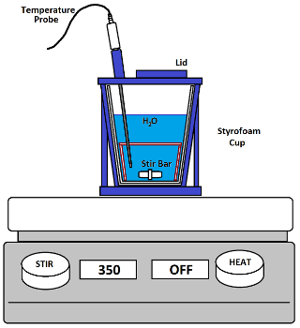
- Place the calorimeter on a COLD stir plate and adjust the stirring rate to 350 RPM.
- Insert the temperature probe and make sure the stir bar is centered and spinning at the bottom.
- Plug the temperature probe into channel 1 and activate LoggerPro.
- When the water heating on the hotplate has been boiling for several minutes, we can assume that the temperature of the water and the copper cylinder are 100ºC.
a. Click the LoggerPro “Collect” button to
begin data acquisition
b. Collect data for 30 seconds
c. Open the lid on the calorimeter
d. Use the tongs to quickly transfer the
copper cylinder to the calorimeter
The copper shouldn’t touch the temp probe.
e. Close the calorimeter lid.
f. Continue collecting data until the
maximum temperature has been
reached and click “Stop”
- Determine the temperature of the water right before the copper was added. This is T_{i}
- Determine the temperature of the water at its highest point. This is T_{f}.
- Empty and carefully dry your calorimeter. Repeat this experiment a second time.

Experimental Procedure 2
Determination of ΔH_{solution}
- Clean and dry the calorimeter.
- Weigh the empty calorimeter
- Add approximately 100 mL of room temperature
distilled water to the calorimeter and re-weigh.
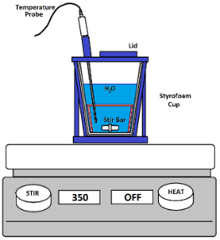
- Place the calorimeter on a COLD stir plate and adjust the stirring rate to 350 RPM.
- Insert the temperature probe and make sure the stir bar is centered and spinning at the bottom.
- Click the LoggerPro “Collect” button to begin data acquisition
- Collect data for 30 seconds
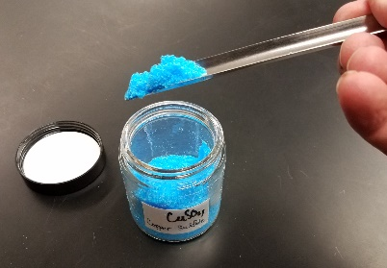
- Open the lid on the calorimeter and quickly add two scoops of the desired solute to the water (pic below)
- Close the calorimeter lid and continue collecting data until the maximum temperature has been reached and click “Stop”

- Determine the temperature of the water right before the solute was added. This is T_{i}
- Determine the temperature of the solution at its highest point. This is T_{f}.
- Re-weigh the calorimeter a third time.
- Dispose of the solution in the appropriate waste container.
- Repeat the above procedure once for each available solute. You can perform these trials in any order:

NaCl
NH₄Cl
CuSO₄ ⋅ 5H₂O
CaCl₂
NaOH

Determination of H_{solution} Name_________________
Minneapolis Community and Technical College Date ________________
Fall 2021 Lab Section ___________

Determination of the Calorimeter Constant C_{calorimeter}

 |  |  | Trial 1 | Trial 2
Calorimeter | Empty Mass | (g)
 | + H₂O Mass (g) | (g)
 | + H₂O + Cu  Mass (g) | (g)
 | T_{i} | (ºC)
 | T_{f} | (ºC)
 | ΔT | (ºC)
 | q_{calorimeter}
 | C_{calorimeter}
 | C_{calorimeter} Average
Water | Mass | (g)
 | Specific Heat | (J/gºC)
 | T_{i} | (ºC)
 | T_{f} | (ºC)
 | ΔT | (ºC)
 | q_{H2O} | (J)
Copper | Mass | g
 | Specific Heat | (J/gºC)
 | T_{i} | (ºC)
 | T_{f} | (ºC)
 | ΔT | (ºC)
 | q_{Cu} | (J)

Heat of Solution trials

 |  |  | NaOH | NH₄Cl | CaCl₂ | NaCl | CuSO₄ •5H₂O
Calorimeter | Empty Mass (g) | (g)
 | Cal + H₂O Mass (g) | (g)
 | Cal + H₂O + solute  Mass (g) | (g)
 | T_{i} (ºC) | (ºC)
 | T_{f} (ºC) | (ºC)
 | ΔT | (ºC)
 | Average C_{calorimeter} | (J/ºC)
 | q_{calorimeter} | (J)
Solution | Mass | (J)
 | T_{i} (ºC) | (ºC)
 | T_{f} (ºC) | (ºC)
 | ΔT | (ºC)
 | q_{solution} | (J)
 | q_{Total} | (J)

Calculated ΔH_{solution} Results (Notice kJ units) …. Use the correct sign for ΔH
 | q_{total} (kJ) | mass_{solute} | moles_{solute} | H_{solution} | H_{known} | **%
NaOH |  |  |  |  | -44.51 kJ/mol
NH₄Cl |  |  |  |  | +14.78 kJ/mol
CaCl₂ |  |  |  |  | -82.88 kJ/mol
NaCl |  |  |  |  | + 3.88 kJ/mol
CuSO₄ •5H₂O |  |  |  |  | +11.7 kJ/mol

** |Experimental – Known|
-------------------------------- x 100 = %
Known

Pages 2 & 3 Show ALL calculations for the five H_{solution} values

Page 4: (...or the last page): Questions

Question 1: Calculate ΔS_{rxn}, ΔH_{rxn}, and ΔG_{rxn} for aqueous CaCl₂ solution formation at 25ºC.

Is the reaction entropy or enthalpy driven at room temperature?
Explain in terms of ΔS_{rxn} and ΔH_{rxn}

Question 2: For each of the solutions formed in today’s experiment, determine if the process is
enthalpy driven, entropy driven, or both.

Question 3: Why was it necessary to weigh the empty calorimeter before each trial?
Question 4: Write a good pre-lab question and answer for this experiment.

