Redox Potentials and the Lead Acid Cell
Minneapolis Community and Tech. College
v.1.16

I. Introduction

Oxidation/reduction chemistry is at the heart of important chemical processes involving electron transfer. One example we’ll be studying in this activity is the voltaic cell. Such devices, often referred to (incorrectly) as batteries, push electrons through wires. These moving electrons are known as electricity and can be used to provide energy to operate electrical devices such as a motors, light fixtures and cell phones. However, before we consider voltaic cells, let’s have a closer look at electricity and what characterizes it.

Electrical Current

Electricity flowing in a wire can be compared to water flowing in a pipe. Let’s say that water is flowing through the pipe at a rate of 2.5 gallons per minute. This quantity is called the “flow rate” and can be used to determine how much water flows in a given amount of time. For example, if a shower head passes water at a rate of 2.5 gal/min, we know that in 5 minutes, 12.5 gallons of water will have flowed!

Of course electrons, not water, flow through wires. This electron flow is known as “current” and is measured in units of charge per second. Since electrical charge is measured in “Coulombs”, electrical current is measured in units of Coulombs/second (C/s). For example, if the electrical current flowing through a wire is known to be 2.5 Ampere (2.5 C/s), we can easily determine that in 5 seconds a total of 12.5 Coulombs will have passed through the wire. Note that 1 C/s is also known as the “Ampere” which is frequently abbreviated as “Amp” or simply “A.”

Electrical Potential (Voltage)
Back to the water analogy! What do you do if you’re camping and you’d like to clean up? You might consider taking a shower but this can be a problem in remote locations. One solution to this problem is the tree shower shown at right where a black bag-like container is filled with water and then tied up in a tree. Over the course of the day, the sun’s rays warm the water so that in the evening you can take a warm shower using the hose that extends downward from the water bag. Although it works, the showering action is weak because of low water pressure which results from the bag being only a short distance from the ground. Of course you could suspend the bag further up in the tree to obtain more water pressure, but this isn’t always practical or safe.

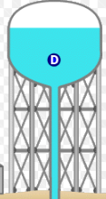
Our domestic water supplies maintain higher water pressures using water towers (left). Water pumped to great heights has more potential energy (P.E.) and resulting in more water pressure for consumers whom have become accustomed to vigorous, satisfying showers. Pumps constantly refill the water tower to maintain constant water height and therefore constant water pressure for everyone.

The electrical analogy to water pressure is “Voltage” or Electrical Potential. This can be thought of as the electrical pressure that pushes electrons through a wire. It is related to the change in P.E. experienced by electrons as they move from high to low P.E. in the same way as water flows from great height (high P.E.) to low height (low PE). Voltage is measured in units of “Volts” which is an abbreviation for Joules/Coulomb.

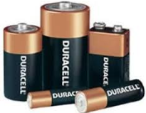
Low voltage or low pressure electricity is what is generated by the “batteries” we buy. Flashlight batteries (1.5 V), Lithium Batteries (3.7 V), rectangular 9 V batteries and car batteries (12 V) are all relatively safe to handle since their electrons are under low pressure. However, it is our relatively dry, insulating skin that protects us from these low voltage sources of electricity. If a battery comes into contact with open wounds where the body’s conductive fluids are exposed, a dangerous and potentially life threatening situation can develop.

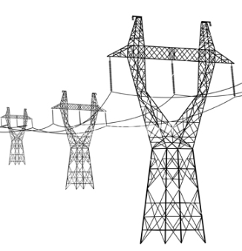
Higher pressure electricity (115 V) is associated with wall outlets. In this case, the body’s dry skin layer isn’t sufficiently insulating to protect us and contact with the exposed terminals of a wall outlet can lead to dangerous electrical shocks.

Extremely high pressure electricity (> 500,000 V) is used to push electrons through high voltage power lines. The voltage is so high that the wires must be suspended high in the air to avoid lightening-like discharges to the ground.

Experimental Part I

When an oxidation-reduction reaction takes place, the oxidation reaction produces electrons that are consumed by the reduction reaction. In a voltaic cell, these two processes occur separately. A wire connecting them to transport the electrons from the oxidation half cell to the reduction half cell. A salt bridge is used to neutralize the charge imbalance that develops when the electrons move from one half cell to the other.

Which species is oxidized and which is reduced has been experimentally determined by comparing each possible half reaction to the Standard Hydrogen Electrode (S.H.E.). Such experiments have produced the table of standard reduction potentials you’ll find in your book where half reactions are listed in order of increasing oxidation ability. Elements found lower on the table with more negative reduction potentials will oxidize if partnered with half reactions positioned higher up on the table.

In today’s experiment you will determine the reduction potentials for a series of four metals. Although reduction potentials are typically measured versus the S.H.E., you will be using a copper electrode Cu⏐Cu²⁺ as the reference electrode (Copper is M₁ in the series of five metals you will examine). This choice in reference electrode simplifies the experiment (the S.H.E. is difficult to construct) but will require you to add 0.34 volts to your measurements to make them comparable to the table of standard reduction potentials.

The role of the copper reference electrode depends on whether copper is being oxidized or reduced. We can easily diagam voltaic cells and their oxidation/reduction half cells using the abbreviated cell notation. The convention requires that the element that is oxidized is listed as the leftmost half cell. Thus, if copper and a mysterious metal “X” are used to construct a voltaic cell and it’s determined that Cu_{(s)} is oxidized, the abbreviated cell diagram would look like:

Anode (-) Cu_{(s)} | Cu⁺²_{(aq)} || X⁺²_{(aq)} | X_{(s)} Cathode (+) (Equation 1)

In the diagram, || is an abbreviation for the salt bridge that connects the two half cells. A single | denotes the interface or contact of the metal and its solution. It is also necessary to have solid conductors on either end of the abbreviated cell diagram. These are known generally as electrodes but more specifically as “Anode” for the oxidation side and “Cathode” for the reduction side of the cell.

If, on the other hand, the Cu⁺² ion was determined to be reduced, then “X” metal would have been oxidized and the abbreviated cell diagram would look like:

Anode (-) X_{(s)} | X⁺²_{(aq)} || Cu⁺²_{(aq)} | Cu_{(s)} Cathode (+) (Equation 2)

In this experiment, five half cells are constructed. By pairing each of the other 4 metals with the copper reference cell, we will measure the potentials for 4 voltaic cells. The half cells are constructed as follows:
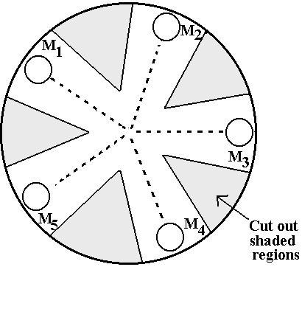
- A round piece of filter paper is cut out to resemble the figure at right.
- A pencil is used to lightly mark the positions of M₁ through M₅ on the outer edge of the filter paper.
- A single drop of a metal ion solution is placed on the filter paper in one of five labeled locations.
- A cleaned piece of the same metal is placed on the appropriate dampened spot. This puts the metal in contact with the aqueous metal solution in the filter paper and completes the half cell.
- A salt bridge is formed by dampening the filter paper with NaNO₃ along a path that connects the two half-cell's whose potential is to be measured.
- Voltage measurements are made using the computer and Logger Pro as a voltmeter.

Experimental Part II

In this experiment, you’ll be constructing a lead acid storage cell, similar to those found in car batteries.

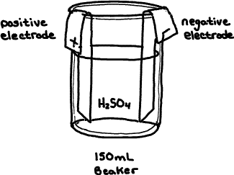
After initial assembly and cell conditioning steps, the cell is charged for different periods of time, a process that converts electrical energy furnished by a power supply into potential chemical energy inside the cell.

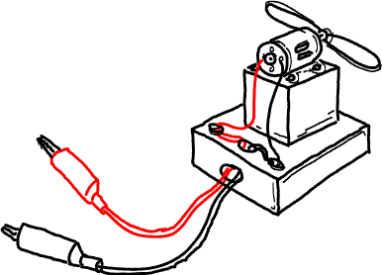
The cell is discharged by attaching it to a small electric motor that spins a propeller. The latter process converts chemical energy into electrical energy and the kinetic energy of the spinning motor/propeller. By comparing the time required to charge the cell to the time it takes the cell to discharge, we are able to determine some of the practical limitations of the rechargeable lead acid storage cell.

When the lead acid cell discharges, the following REDOX reaction takes place:

Discharge: Pb_{(s)} + PbO_{2(s)} + 2H₂SO_{4(aq)} → 2PbSO_{4(s)} + 2H₂O_{(l)} + Energy

The energy is available to the electric motor as electrons that flow (electricity) from the negative anode (Oxidation Reaction) through the device and to the positive cathode (reduction reaction). The oxidation and reduction reactions shown below occur at the surface of the two lead electrodes:

Oxidation (- Anode): Pb_{(s)} + HSO⁻_{4(aq)} → PbSO_{4(s)} + H⁺_{(aq)} + 2e⁻

Reduction (+Cathode): PbO_{2(s)} + HSO⁻_{4(aq)} + 3H⁺_{(aq)} + 2e⁻ → PbSO_{4(s)} + 2H₂O_{(l)}

As you know, no battery lasts forever. When a battery or cell “dies”, it has simply run out of reactants at which point the discharge reaction can no longer take place. The limiting reactant in our lead acid cells, is the lead oxide: PbO₂. Once all the lead oxide is gone, the cell cannot produce any more energy.

Lastly, lead acid cells are secondary cells. This means that they can be recharged; a process that reverses the reaction above and converts products back into reactants:

Charge: 2PbSO_{4(s)} + 2H₂O_{(l)} + Energy → Pb_{(s)} + PbO_{2(s)} + 2H₂SO_{4(aq)}

To recharge the cell, we must furnish energy since it’s a reactant. This energy is converted into the stored chemical potential energy of the reactants which is available to us later.

II. PRELAB EXERCISE

Clearly answer these questions in INK in your lab notebook before coming to lab.

1. Consider the following two ½ reactions in the order observed in the standard reduction tables.
Cu²⁺_{(aq)} + 2e- Cu(s) Eº_{red} = 0.34 V
Sn²⁺_{(aq)} + 2e- Sn(s) Eº_{red} = -0.14 V

a. Identify which metal should be oxidized and which ION should be reduced.

b. For the two ½ reactions above, determine the net cell reaction.
Do this by re-writing (reversing) the oxidation reaction with the electrons written as products.
Combine it with the remaining reduction reaction cancelling duplicate terms.

c. For the two ½ reaction above, construct the abbreviated cell diagram (refer to equations 1 & 2).
Remember that the oxidation half-cell is always positioned on the left.

2. What are the problems associated with clean, renewable energy sources like solar and wind power?

III. Word Processed Report
Page 1: Upper right hand corner Name, Lab section number and date

→ Part IV A: Data table

Metal | Measured Potentials (V) | Adjusted Potentials (V) | Known Standard reduction potentials | Δ%
M₁ (Cu) |  |  | +0.34 V
M₂ (Zn) |  |  | -0.76 V
M₃ (Pb) |  |  | -0.13 V
M₄ (Ag) |  |  | +0.80 V
M₅ (Al) |  |  | -1.66 V

Instructions:

1. Adjusted Potential: To make your potential values comparable to those found in Appendix D, you must add 0.34 Volts from each measured potential.

2. Calculate the delta % for M₂ through M₅ as follows: delta % = (Eº_{Adjusted} - Eº_{known}) / Eº_{known} x 100
Depending on whether your results are higher or lower than the known value, the delta % may be positive or negative.
Be sure to include + or – as part of your answer.

→ Part IV B: Discharge Time vs. Charge Time Graph

- The usual: Graph title, axis labels w/units, etc.
- Clearly identify the following two regions on your graph:
        - Use the label “Charging” for that region where additional cell charging results in additional discharge time.
        - Use the label “Overcharging” for that region where additional charging results in no additional discharge time.

Page 2: Answers to the following questions:

- For each of the 4 metal pairings you tested in Part 1 (Cu-Zn, Cu-Pb, Cu-Ag and Cu-Al), determine…
  - Which metal is oxidized and which ION is reduced.
  - The abbreviated cell diagram (refer to equations 1 and 2 above)

- A battery is two or more individual cells connected together. Some large trucks utilize large 24 volt lead acid batteries. How many lead acid cells would be required to construct a battery with this voltage?
3. Based on the lead acid battery discharge reaction explain why "run-down" or discharged car batteries are in greater danger of freezing than charged lead acid batteries.

4. What were the identities of the gases you saw being produced at the + and - electrodes during the cell conditioning process? Why does the presence of these gases make charging a lead acid cell a dangerous activity especially when “jump” starting your car?

5. Based on your Discharge Time vs. Charge Time graph, consider the extent of the “Charging” region and determine the optimum charge time (seconds) for your cell. If you continue to charge beyond this time, where does the extra energy go?

IV A. Procedure Potential Measurements

Set up your computer and Loggerpro data collection equipment in the hood.

Boot up your computer, launch the Logger Pro application and open the file called MCTC REDOX. Insert the differential voltage probe assembly into port 1 of the interface box.

* Inspect the test leads of the voltage sensor (red (+) and black (-) alligator clips) and if they are corroded or dirty, clean the tips with the green abrasive pad.

Voltmeter Calibration

Before measuring any voltages, it will be necessary to calibrate the logger pro voltmeter with two known voltages.

In Logger Pro, click on
Experiment Calibrate Calibrate Now.

Clip the red and black wires together. Enter “0” in the first calibration box and then click “Keep” to finalize the point.

Next , connect the red lead to the “+” terminal and the black lead to the “-“ terminal of the 1.5 volt calibration battery. Enter the accurate calibration voltage (determined at the beginning of lab) in the second calibration box. Click “Keep” and then “Done”.

The voltmeter is now calibrated.

Obtain a piece of filter paper and with a pencil, lightly draw five small circles with connecting lines, as shown in the figure at right. Cut wedges between the circles as shown. Label the circles M₁ … M₅ near the outer edge of the filter paper.

Obtain 5 vials that contain the 5 metal samples. Use the green abrasive pad to clean the front and back sides of each metal sample. Be sure to remove any deposits and expose bright, shiny metal on both sides of the metal sample. Avoid touching the metal surfaces as skin oils will interfere with the electrical connections and your measurements.

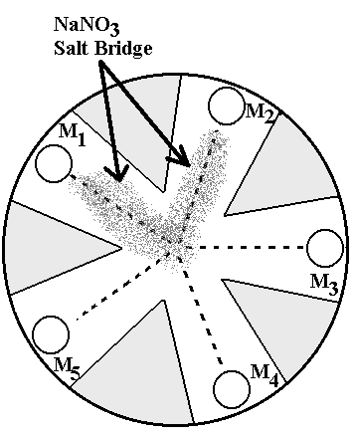

Place 1drop of the M₁ (Copper II) solution on its circle on the filter paper. Then place the M₁ metal piece on top of the solution spot. Place 1-2 drops of another metal solution (e.g. M₂) on its respective position on the filter paper along with its metal piece.
*Avoid opening more than one solution bottle at a time to avoid misplacing an eye dropper in the wrong bottle and cross-contaminating the solutions.

Use the 1.0 M NaNO₃ to moisten the paper and create a narrow path that connects the two metal damp spots.

Firmly touch the tip of the black voltage probe to the M₁. Firmly touch the tip of the red voltage probe to the other metal (M₂, M₃, M₄, or M₅). Record the voltage you measured (include the -/+ sign) . Also record your results on the blackboard for comparison.

*Be careful not to wet the top surfaces of any metal pieces. Doing so will affect the accuracy of your measurements.

Using M₁ as the reference electrode, repeat this procedure for metals 3 - 5.

*It may be necessary to re-wet the M₁ spot and the salt bridge region periodically as they tend to dry out.
Clean up

Remove each metal sample using a tweezers. Rinse each metal sample with distilled water and thoroughly dry the sample with a paper towel before returning it to the correct vial. Dispose of the filter paper in the large marked beaker at the side of the lab.

IV B. Procedure Lead Acid Cell
Cell construction and Charging:
The cells are already assembled and available on the benchtop (see figure at right). The positive (+) electrode will have a brown PbO₂ coating. The negative
( –) electrode will be gray in appearance (Pb).

Position the electrodes at opposite sides of the beaker and don’t move them again throughout the experiment.

* Do not touch these coatings as they are necessary for proper cell operation and can be easily ruined.

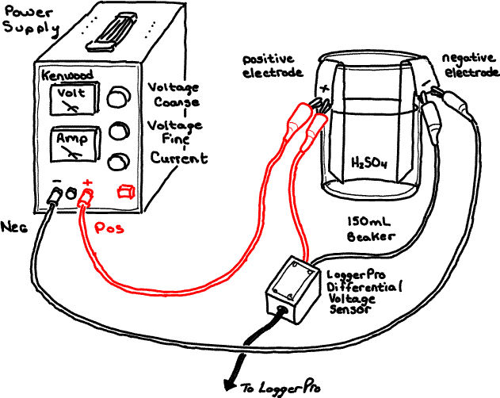
Add approximately 100 mL of 1.0 M H₂SO₄ to the cell assembly. Do not adjust the level of H₂SO₄ at any other time during the experiment.

* Be sure the power supply is TURNED OFF when making the following connections…

* Keep the electrodes at opposite sides of the beaker and NEVER let them touch each other.

Referring to the diagram above, use a red wire to connect the positive terminal of the power supply to the cell’s positive electrode. Use a black wire to connect the negative power supply terminal to the negative electrode.

Now connect the red and black clips of the LoggerPro differential voltage probes to the positive and negative terminals of the cell respectively. (Match colors)

Power Supply Control Settings:

Current control: Full Clockwise
Coarse Voltage control: Full Counter Clockwise
Fine Voltage control: Midway position.

Cell Conditioning:

Before performing experiments with the lead acid cell, it is necessary to condition the cell and clean the electrode surfaces. The cell conditioning procedure below charges the cell at high current and builds up a fresh coating of PbO₂ on the positive electrode.

Have your instructor check your wiring before continuing with the next steps!

Turn on the power supply and adjust the coarse voltage knob for a voltage of about 4 volts as displayed on LoggerPro computer screen readout.

* Avoid breathing the gases that are produced.

Continue this process for 3 minutes.

Disconnect the cell from the power supply by unplugging the red and black wires from the front of the power supply
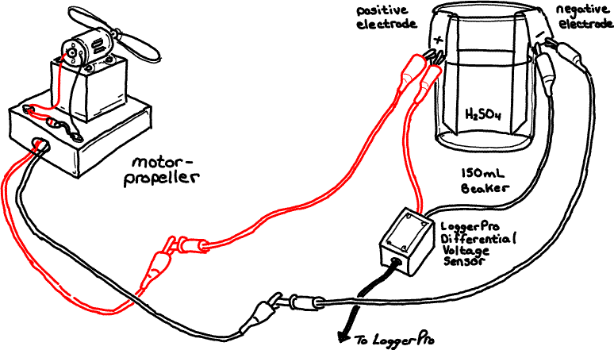
Connect each of these wires to the wires of the electric motor/propeller assembly (figure below). The propeller will begin to spin as the cell discharges.

Continue to let the cell discharge until the motor has stopped (Typical times approx. 45-60 seconds) and repeat the above conditioning procedure one more time.

Charge/Discharge Investigation

Completely discharge the cell.

Reattach the cell to the power supply and set the power supply voltage to 3.0 volts using the coarse voltage control knob and the computer display.

Again, completely discharge the cell.

Now that the power supply has been set for 3.0 volts, you can attach the cell to the power supply and use a stopwatch to charge the cell for exactly 10 seconds.

Disconnect the cell by removing the wires where they plug into the power supply. Attach the cell to your motor and simultaneously start your stopwatch.

Record the time when the motor stops running.

Repeat the experiment for 15, 20, 30, 40 and 60, 90 and 180 second charge times.

*Charge the cell one last time
for 60 sec. and set it aside.
Your instructor will transport the cell to the front bench where it will be used as part of a post lab discussion.

Clean up

Do not remove the electrodes from the beaker at any time. Keep the cell assembled. Your instructor will clean up the lead acid cell at the end of the day.

