**Solubility of a Salt**

**Minneapolis Community and Technical College**

**Principles of Chemistry II, C1152   
*v.5.19***

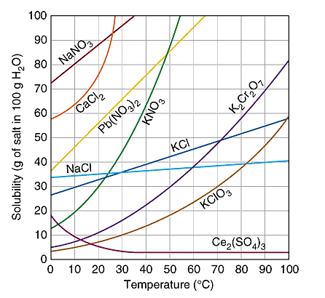

**I. Introduction**

**Solutions** are **homogeneous** **mixtures** made up of one or more **solutes** dissolved   
in a **solvent**. The solvent is the component present in the greatest amount.

**Unsaturated solutions** are able to dissolve even more solute than has already dissolved.

**Saturated solutions** contain as much dissolved solute as is possible at that temperature.

**Supersaturated solutions** have more solute dissolved than should be possible and are quite unstable. *When a supersaturated solution is disturbed, the excess solute will precipitate leaving behind a saturated solution and solid solute that settles to bottom of the container.*

**Solubility** is defined to be the maximum amount of solute that will dissolve in a given amount of solvent at a specific temperature. In this experiment, solubility is reported in grams of solute per 100g of solvent Note that as demonstrated by the graph above, the solubility of many salts increases with increasing temperature.

We can use solubility information to make predictions about how much solute will dissolve in a given amount of solvent. For example, the solubility of NaCl in water at 20°C is 36 grams per 100 g water. If you attempt to dissolve 40 grams of NaCl in 100 mL of water, 36 grams will dissolve to form a saturated solution and the remaining 4 grams will settle to the bottom of the container.

**Dynamic equilibrium** occurs when the rates of two opposite processes are equal. When solid solute is in contact with a *saturated* solution, the solid continuously ***dissolves*** AND ***reforms.*** Note that the mass of the solid never changes because salt that dissolves is immediately replaced by aqueous ions depositing on the surface of the solid.

**Today’s experiment:** In this experiment, you will determine the temperature dependence of potassium nitrate’s solubility in water. You will prepare four different solutions, each containing a different amount of KNO3 dissolved in 5 mL of water. Each vial is then stirred and heated until all of the solid dissolves.

After the solid completely dissolves, the stirred solution is slowly cooled. When the **saturation temperature** is reached, solid solute will be observed as small solid crystals resembling snow flurries. The saturation temperature when crystals are first observed is recorded for each trial solution twice and the results averaged.

Knowing the saturation temperatures for each solution lets us to construct a solubility graph (solubility**y** vs. temperature**x** ) with solubility in units of grams solute/100 grams solvent. After plotting the temperature and solubility data, a linear and second order polynomial trend line analysis of the data is performed. The best fit for the data will then be used to determine the composition of an unknown sample.

**II. Prelab Exercise…** ***Clearly answer these questions in INK in your lab notebook before coming to lab.***

1. Referring to the procedure described below, why isn’t it a good idea to heat your salt/water mixtures to temperatures much higher than the saturation temperature?

2. The friendly chemist believes that an NaCl solution is *saturated*. How could she confirm this with an experiment?

3. 2.31 grams of KNO3 are dissolved in 4.15 g of H2O.

What is the concentration of the solution in units of gKNO3/100gH2O?

4. 50.0 grams of KCl are dissolved in 200 grams of water at room temperature. (hint: use the graph above)

What is the resulting solution? a. unsaturated, b. saturated c. super saturated.

**III. Word Processed Report**

**Page 1:** *Upper right hand corner Name, Lab section number and date*

**Graph**

* Use Excel to construct a data table including mass KNO3, mass H2O, T (oC), Solubility (gsalt/100 gsolvent) for the four known trials. Remember, Excel graphs work best if “X” values are in the left hand column.
* Construct a solubility graph using the temperature and solubility information for the four known trials. (Use the scatter plot option but do not connect the dots.)
* Include axis titles (w/units) and an appropriate graph title.
* Perform a **linear** and **second order** polynomial trend line analysis on the data.   
  + Display the equation and R2 value for both trend lines on the same graph.
  + Adjust the number of decimal digits of all trend line equations to 8 or greater.
  + 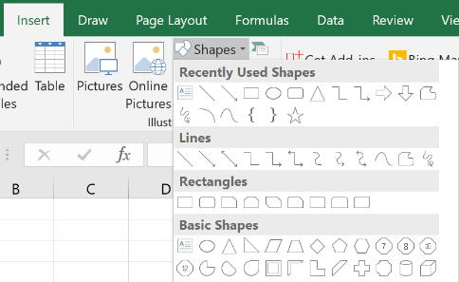Use a textbox to clearly label the best trend line with the word “**Best**.”   
    *(The equation that best fits the data will have an R2 value closest to 1.)*
* Position the unknown’s data point (solubility,temperature) on your graph using  
   “insert” 🡪 “Shapes” 🡪 “Circle” and label it using a textbox:
  + the unknown number
  + the solubility value (calculated below)
  + the saturation temperature
* Use an Excel textbox to CLEARLY label the regions of the graph that correspond to *saturated*, *unsaturated* and *supersaturated* solutions.

**Page 2:**  **Data Table:** Create a data table with all relevant information and copy/paste it into your report.

Your report must be turned in as a single .pdf document.

**Questions:**

* 1. Use your unknown’s saturation temperature to determine its solubility value using the best trend line analysis result from your graph. Show your hand written calculations and round your final result to the correct number of significant figures. This value will be compared to the known value to determine your grade for the unknown.
  2. Use your graph to determine if the following solutions are unsaturated, saturated, or super-saturated. If the solution is supersaturated, determine the excess amount of solute. If the solution is unsaturated, determine the mass of additional solute that could be dissolved.
     1. 50 g of KNO3 in 50 g of water at 35oC
     2. 45 g of KNO3 in 100 g of water at 50°C
     3. 60 g of KNO3 in 200 g of water at 20oC
  3. According to your trend line analysis, how much KNO3 will dissolve in 250. g of water at 45.oC? (Show all work)
  4. 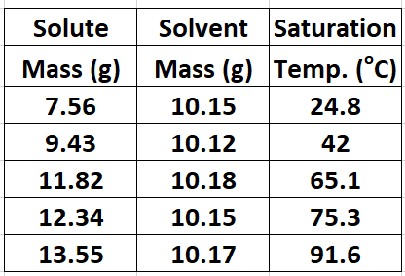Creating supersaturated solutions is tricky business. Find out how it can be done and describe the key aspects of this procedure in your own words.
  5. Compare your unknown’s concentration with the its position within the standard lineup. Does the comparison support your experimental concentration determination? Explain.
  6. Analyze the data at right (show all work) and predict the saturation temperature for a sample made up of 16.37 grams of dissolved solute in 15.34 grams of solvent.   
       
     Experimentally, the unknown’s saturation temperature is determined to be 44.5oC.  
     How does this result compare to your prediction? If not comparable, what might explain the differences?

**IV. Procedure**

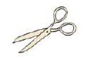

**Logger Pro File:** *Solubility of a Salt*

You will be performing today’s experiment with a partner.

Construct the ring stand apparatus shown below. The vial and temperature probe should be securely clamped so that the entire apparatus can be moved as a whole.

Two stir plates are required. Only one is equipped with a hot water bath (50 mL beaker) for heating purposes. The other hotplate is used only to stir the vial while it cools slowly.

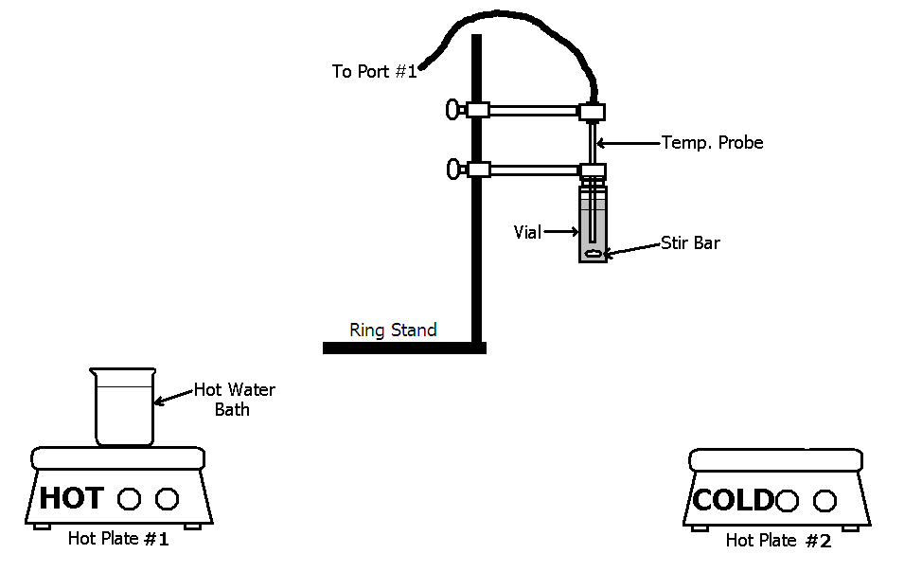

**Keep wires away from the hot plate or they will melt and burn!!!**

1. Heat First   
 (Hotplate)

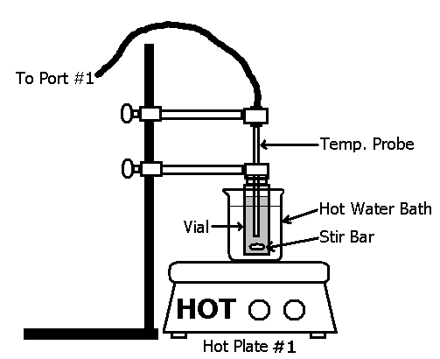Move the ring stand apparatus as a unit between the two stir plates as needed.

Obtain four vials and label each appropriately writing the vial number on the lid with a marker.   
  
Weigh each vial using a *top loading balance* with their caps on. Record the mass of each in your notebook.

|  |  |
| --- | --- |
| Vial # | KNO3 mass (g) |
| 1 | *Approximately* 6 g |
| 2 | *Approximately* 4.5 g |
| 3 | *Approximately* 3 g |
| 4 | *Approximately* 2 g |

On a piece of *creased* weighing paper, measure out the amount of KNO3 given by the table below.

Transfer the solid to the appropriate vial and   
reweigh the vial/cap to accurately determine the amount of solid transferred. Repeat this procedure for all four vials.

Pipette 5.00 mL of distilled water into each vial. Re-weigh each vial to determine the amount of water actually transferred to the vial.

Obtain an unknown from your instructor and use its color to determine its position within the standard solutions you’ve created. Note this position in your lab notebook.

Remove the cap from vial #1 and insert the magnetic stir bar. Use clamps to support the vial in the hot water bath (*50 mL beaker*). Note that the bottom of the vial must be centered on the stir plate and close (1-2 cm) to the bottom of the water bath for the magnetic stirrer to work. The hotplate should be set at 300oC and 900 RPM stir rate.

2. …then cool   
 (Cold plate/ice)

Continue heating the solution until the solid has dissolved. Do not leave the vial in the water bath any longer than what is required to completely dissolve the solid.

When the KNO3 has completely dissolved, lift the *entire ring stand apparatus* and reposition it over the cold stir plate. Continue stirring. Allow the vial to cool slowly. More dilute solutions may require the direct application of ice to reach cool enough temperatures in a *reasonable* amount of time.

Crystals will suddenly form and build in intensity quickly over approximately 2 seconds.

Record the temperature at the first sign of crystal formation.

Reheat the vial/solution and repeat the cooling process (always stirring) a second time and average your two temperature results. Report the average value in your data table.

Repeat this process for the remaining three vials and your unknown vial. Be sure to record your unknown’s code number in your notebook.



**Other Useful Experimental Hints:**

* Rinse and dry the temperature probe in between experiments to minimize solution cross contamination.
* For the more concentrated solutions, it may be necessary to begin stirring with the temperature probe as the stir bar is initially overwhelmed.   
    
  Use a back and forth motion to break up the solid KNO3 at the bottom of the vial.
* A small piece of ice held at the bottom of the vial will accelerate the cooling process making it possible to determine an approximate saturation temperature.  
    
  Once determined, you can go back and cool more slowly for two more accurate saturation temperatures.
* Use the magnet on a stick to retrieve the stir bar from the waste solution container.

**Cleanup**:

* Empty each vial in the appropriate "KNO3 student waste" container when finished.   
    
  Do not dispose of solutions down the drain.
* Use a distilled water squirt bottle to rinse any solid KNO3 sticking at the bottom of the vials into the waste container.
* Place used & rinsed vials upside-down in the dishwasher rack at the rear of the lab.
* Dry your glassware and neatly arrange it on the benchtop.
* Obtain 3 new vials from your lab instructor and place them with your other equipment.
* Wipe down your benchtop and around the balance areas. (Do not wipe down the balances.

**[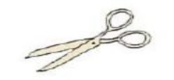](http://rds.yahoo.com/_ylt=A9G_RquVQvJEWOgAz7qJzbkF;_ylu=X3oDMTBjYzZubXM2BHBvcwM4BHNlYwNzcg--/SIG=1i87bv1od/EXP=1156813845/**http:/images.search.yahoo.com/search/images/view?back=http://images.search.yahoo.com/search/images?p%3Dscissors%26tab%3DImages%26ei%3DUTF-8%26fr%3Dmy-vert-img-top&w=152&h=102&imgurl=www.rockingham.k12.va.us/sound_sorting/final_consonants/_r/images/scissors.jpg&rurl=http://www.rockingham.k12.va.us/sound_sorting/final_consonants/_r/pages/scissors.htm&size=15.1kB&name=scissors.jpg&p=scissors&type=jpeg&no=8&tt=239,859&oid=307b75a1a72d8716&ei=UTF-8)V. Data Table:** Cut and paste this data table into your lab notebook using glue and transparent tape.

***Use excess significant figures at all times unless asked to round.***

|  |  |  |  |  |  |  |  |  |  |
| --- | --- | --- | --- | --- | --- | --- | --- | --- | --- |
| ***Vial #*** | ***Mass of Vial with cap***  ***(g)*** | ***Mass of vial with cap  & KNO3***  ***(g)*** | ***Mass of vial with cap & KNO3  & H2O***  ***(g)*** | ***Calculated  Mass of KNO3***  ***(g)*** | ***Calculated Mass of H2O***  ***(g)*** | ***Solubility***  ***(g)KNO3/100g H2O  Graph Y*** | ***Temperature. Trial #1   (°C)*** | ***Temperature Trial #2   (°C)*** | ***Average***  ***Temperature***  ***Graph X***  ***(°C )*** |
| **1** |  |  |  |  |  |  |  |  |  |
| **2** |  |  |  |  |  |  |  |  |  |
| **3** |  |  |  |  |  |  |  |  |  |
| **4** |  |  |  |  |  |  |  |  |  |
|  | **Unknown Number**  ­­­­­­­ | | | **Unknown Solubility Use Correct Sig. Figs.** | | |  |  |  |